

Dealer Inventory Management

DP Concept

Document type: DP Concept

Reference: S&D/PSP-2002 / 13040125 / BDV1

Version: 1.55 from 01.03.2022

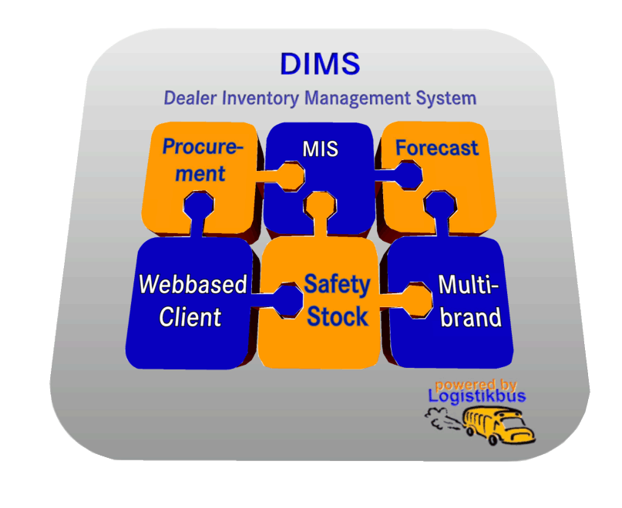

|  |  |  |  |  |
| --- | --- | --- | --- | --- |
| Proof of change | | Document reference: S&D/PSP-2002 / 13040125 / BDV1 | | |
| Authors:  Tobias Soder,  Jessica Hatz | Review through: | Version: 1.55 From: 01.03.2022 |
| Version number / date | | New / changed chapters | Change type | Comments |
| 0.5 | 15.04.2002 | all | New creation |  |
| 0.9 | 03.06.2002 | all | Corrections |  |
| 0.91 | 07.06.2002 | 2, 3, 4, 5 | Corrections | GSSN import extended,  interface extended |
| 0.92 | 25.10.2002 | 1,3,5 | Corrections | Premise changed. GSSN import changed. Table added. |
| 0.93 | 20.01.2003 | 4 | Additions | For renumbering actions, additional tables have been added in which changes have also been made. |
| 0.94 | 17.05.2004 | 4 | Additions | The concerned tables from SICOS, 8-digit third-party suppliers, multibrand and traceability were included. |
| 1.0 | 10.04.2006 | 4 | Additions | Chapter has been updated. All tables to be renumbered are now listed. Procedure for Commit per Location is described. |
| 1.1 | 04.09.2006 | 2 | Additions | Changes for Release 28 have been incorporated (contact person for disposition). |
| 1.2 | 17.10.2006 | 2 | Additions | Email field with scroll bars, permission to change of locations. |
| 1.2.1 | 18.10.2006 | 2 | Additions | Assortment analysis included. |
| 1.2.2 | 06.11.2006 | 2 | Additions | Change state Save button when changing data. |
| 1.2.3 | 30.10.2007 | 3 | Corrections | Modify GSSN import ( country-specific files) |
| 1.3 | 20.02.2008 | 3.2.1 | Additions | Procedure of local implementation specified in detail. |
| 1.4 | 31.03.2008 | 4 | Additions | Extend renumbering CORS |
| 1.5 | 25.04.2008 | 3.2 | Additions | Separate FTP access of GSSN import for Daimler and Chrysler |
| 1.6 | 23.02.2010 | 4.7, 4.8, 5.1 | Additions | Execution in 2 steps, change VP after NDL |
| 1.7 | 11.06.2010 | 4.2, 4.3, 4.4 | Additions | New table BETRIEBS_KONTAKTE |
| 1.8 | 21.12.2011 | 2.7 | Additions | New fields DMS and DMS version |
| 1.9 | 20.01.2015 | 3 | Additions | Modify renumbering for the topic ID212 Mapping of different customer numbers to one main company |
| 1.10 | 21.01.2015 | 2.9 | Additions | ID171 Information panel |
| 1.11 | 12.02.2015 | 2.9 | Additions | ID171 Information panel after feedback from Daimler |
| 1.12 | 13.02.2015 | 4 | Additions | Modify renumbering for  ID195 MARKET_AREA_MEMBERS |
| 1.13 | 26.02.2015 | 2.9 | Additions | ID171 Information panel after feedback from Daimler |
| 1.14 | 04.03.2015 | 2.8 | Additions | ID195 Cross-reference to MAD concept |
| 1.15 | 05.03.2015 | 2.8 | Additions | ID195 MAD integrated |
| 1.16 | 09.03.2015 | 2.8 | Additions | ID195 MAD additions according to customer feedback |
| 1.17 | 10.03.2015 | 2.8 | Additions | ID195 MAD additions according to customer feedback |
| 1.18 | 17.03.2015 | 2.8 | Additions | ID195 MAD additions according to customer feedback |
| 1.19 | 06.05.2015 | 2.8 | Additions | ID195 MAD additions according to customer feedback |
| 1.20 | 25.06.2015 | 2.9 | Additions | ID171 Information panel changes during implementation |
| 1.21 | 26.08.2015 | 4.2, 4.3, 4.4 | Additions | DIMS 2.0 Renumbering tables |
| 1.22 | 10.12.2015 | 2.9 | Additions | ID171 Information panel changes after implementation |
| 1.23 | 19.04.2016 | 3.3 | Additions | ID344: Prevent import of deactivated dealers |
| 1.24 | 31.08.2016 | 2.10, 5.1 | Additions | ID306: Redesign CCC process China |
| 1.25 | 25.09.2016 | 5.1 | Additions | ID363: Extend dealer data |
| 1.26 | 21.10.2016 | 4.4 | Additions | DGS-Controlling renumbering |
| 1.27 | 15.02.2017 | 3.3 | Additions | EPM103.2: Mail dispatch in UTF-8 |
| 1.28 | 12.05.2017 | 2.11.1, 2.11.2 | Additions | ID346: Contact person 1st Level Support and dealer group |
| 1.29 | 16.05.2017 | 3.4 | Additions | ID406 Map dealer type |
| 1.30 | 22.05.2017 | 2.11.3 | Additions | ID394: Equipment and parameterization |
| 1.31 | 06.06.2017 | 2.11.3 | Additions | ID394: Equipment and parameterization |
| 1.32 | 31.07.2017 | 2.11.3 | Additions | ID394: Equipment and parameterization |
| 1.33 | 03.01.2018 | 2.7.1  4.2, 4.3, 4.4 | Adjustments | ID432: DMS,  ID407: JCFR (renumbering) |
| 1.34 | 22.01.2018 | 4.3  2.11.1 | Adjustments | ID456: VD supplier record for  separating  ID346: modify after acceptance |
| 1.35 | 02.02.2018 | 4.2, 4.3, 4.4 | Adjustments | ID453 Renumbering USA Rollout |
| 1.36 | 28.02.2018 | 2.11.2 | Adjustments | ID346 Adjustments from Bugzilla bug 2304 |
| 1.37 | 05.03.2018 | 4.9, 5.1 | Adjustments | ID445 Interim process renumbering |
| 1.38 | 20.04.2018 | 2.11.2 | Adjustments | ID346 Adjustments from Bugzilla bug 2304 (delete button) |
| 1.39 | 16.07.2018 | 4.5, 4.9 | Adjustments | ID488 GUI adjustment for interim process renumbering |
| 1.40 | 13.09.2018 | 1.1, 3.1, 3.2 | Adjustments | ID469 Migration GSSN |
| 1.41 | 16.01.2019 | 4.2, 4.3, 4.4 | Adjustments | ID428: Deconstruction of old parameterization |
| 1.42 | 06.08.2019 | 3.2 | Adjustments | ID469.2 GSSN dealer data mapping |
| 1.43 | 26.09.2019 | 2.7.1, 2.9.1.6, 5.1 | Adjustments | ID458: D2D |
| 1.44 | 21.10.2019 | 4.2, 4.4 | Adjustments | ID466: SALES_DEALERS |
| 1.45 | 08.11.2019 | 3.1, 3.2, 5.1 | Adjustments | IT100: GSSN field "companyId |
| 1.46 | 22.04.2020 | 4.10 | Adjustments | IS.017: Optimization of runtimes |
| 1.47 | 18.05.2020 | 4.2, 4.3, 4.4 | Adjustments | CO.R1-59.2: Renumbering CORS |
| 1.48 | 04.08.2020 | 4.2, 4.3, 4.4 | Adjustments | ID458: Downtimes |
| 1.49 | 11.03.2021 | 2.12, 5.1 | Adjustments | ID567: Additional selection criteria BW |
| 1.50 | 15.04.2021 | 3.2, 6.1 | Adjustments | IS025 Switch for GSSN Import to GSSN+ API |
| 1.51 | 08.06.2021 | 3.2, 6.2 | Adjustments | IS.028 GSSN+ Implementation |
| 1.52 | 29.07.2021 | 2.13 | Adjustment | ID596 User Information Cleanup_DSGVO |
| 1.53 | 18.08.2021 | 2.13 | Adjustment | ID596 Addition after feedback from Daimler |
| 1.54 | 10.12.2021 | 2.14 ,5.1 | Adjustment | ID 604 Enable MBCS feedback |
| 1.55 | 01.03.2022 | Distribution list, 3.2 | Adjustment | ID 609 GSSN Update with Conversion |

|  |  |  |
| --- | --- | --- |
| Distribution list | | |
| Organizational unit / ­company | Name / Address | Number of copies |
| Mercedes-Benz Group AG | Frank Beck | 1 |
| Mercedes-Benz Group AG | Jacek Lipinski | 1 |
| Mercedes-Benz Group AG | Thorsten Nau | 1 |
|  |  |  |
|  |  |  |
| T-Systems | Jürgen Sauer  [juergen.sauer@t-systems.com](mailto:juergen.sauer@t-systems.com) 089 54550-4636 | 1 |
| T-Systems | Tobias Soder [Tobias.Soder@t-systems.com0721-351-1093](mailto:Tobias.Soder@t-systems.com) | 1 |

Table of contents

1 Introduction 8

1.1 References 8

1.2 Restrictions 8

1.3 Premises 8

2 Dealer Master Data 9

2.1 General 9

2.2 Interface 9

2.3 Dealer Search 10

2.4 Copying and creating new dealers 11

2.5 Enhancements for Release 28 12

2.5.1 Changes to the interface 13

2.5.2 Permissions 13

2.5.3 Entering E-mail addresses 13

2.5.4 Database extension 14

2.5.5 Modifying dependent modules 14

2.5.6 Initial filling 14

2.6 Enhancement for Release 31 14

2.7 Enhancement for Release 38 15

2.7.1 DMS display in Dealer Data 15

2.8 Extension for special patch 42.4.1.0 17

2.8.1 New panel "Market Area Demand 17

2.8.2 Authorization concept M.A.D. 20

2.9 Enhancement for Release 43 21

2.9.1 New subpanel "Notes“ 21

2.10 Enhancements for Release 47 - "Dealer parameters" panel 31

2.11 Enhancements for Release 50 32

2.11.1 Contact person 1st level support 32

2.11.2 Dealer parameter “Dealer group" 33

2.11.3 Creation and parameterization of new dealers 36

2.12 Changes for Release 62 40

2.12.1 Dealer Timezone 40

2.13 Changes for Release 64 41

2.13.1 Deletion of access rights in LPBS 41

2.14 Changes for Release 66 41

2.14.1 New database columns for project Returns MBCS 41

3 Import data from GSSN 42

3.1 General procedure 42

3.2 GSSN import process 43

3.3 Inactive dealers 46

3.3.1 Local conversion 47

3.4 Mapping Dealer Type 47

4 Change of Dealer numbers 48

4.1 General 48

4.2 Renumbering 48

4.3 Separation of Dealers 50

4.4 Merging dealers 51

4.5 Interface 55

4.6 Implementation in general 56

4.7 Implementation in 2 steps 57

4.8 Renumbering from VP to NDL 58

4.9 Renumbering of Interim Process 58

4.10 Optimization of runtimes 59

5 Implementation 60

5.1 Database 60

6 Annex 64

6.1 Identification of the main and connected dealer 64

6.2 GSSN+ API request with brand code: /v1/outlets/search 65

1. Introduction

## References

* DV concept supplier’s parameterization   
  (Document reference: R&D/SPL-2001 / 13040113 / TS-LP1)
* DP concept authorization concept DIMS
* DV concept R34P - GSSN local implementation

## Restrictions

The topics of cost allocation and the return process will only be considered in later stages and are therefore not yet dealt with in this concept.

The topic of authorizations is currently being conceptualized. As soon as this is done, user authorizations concept will be remodeled.

## Premises

* The authoritative system for the dealer inventory is GSSN
* It is assumed that the inventory quality required (correctness and completeness) for GSSN is ensured.
* DAG provides data that allows the conversion of GSSN-wide location numbers to Logistikbus-wide location numbers.

1. Dealer Master Data

## General

When the user logs on, the associated start dealer number is read on the client from a locally stored configuration file. If this information (User’s first login from this client) is not available, an empty dialog box appears, where a dealer number must be entered first.

## Interface

The master data (1) includes general address data, the dealer type and status of the dealer (Active or Inactive). Each dealer for which the user has view-only rights (e.g., a main dealer with connected dealer) can be saved as a start dealer, i.e., it will be displayed first the next time the client is started. In addition, all related dealers (main and connected dealers) are displayed in a table. All of this data is imported from the GSSN and cannot be changed here.

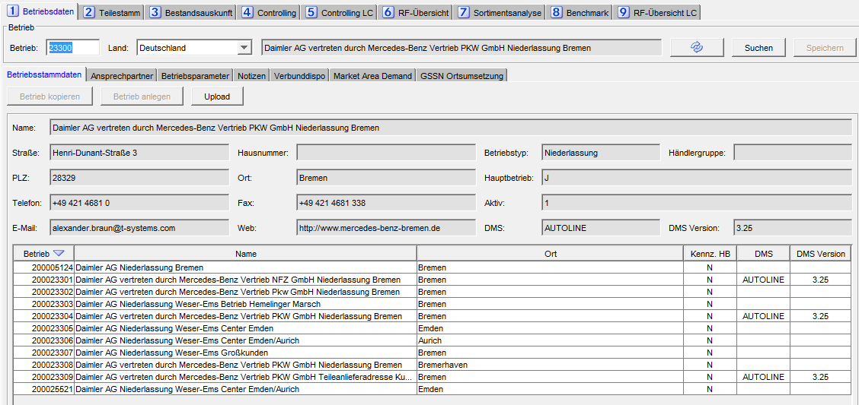

Table contains all related dealers (main dealer and all connected dealers). The right column (link) can be used to switch to the corresponding dealer.

In addition, the name, e-mail, telephone, and fax number of the person responsible for inventory management for a dealer can be entered. This information is maintained and stored here by the retail dealer.

The dealer required is selected in the header field. The country code is entered directly or selected from a drop-down menu. The dealer number can also be entered directly. A dealer can be searched by the dealer’s name, postal code, telephone area code or dealer number, whereby it is also sufficient to enter parts of the respective search term (Figure 2‑1).

The master data (2) includes customer numbers of other brands (e.g., Evobus, Unimog), which are maintained here. In addition, the DIMS status of the dealer can be changed here. Disposition and order forwarding are only done for active dealers. The current status is displayed, the new status with deadline and the parameters necessary for activation can be entered.

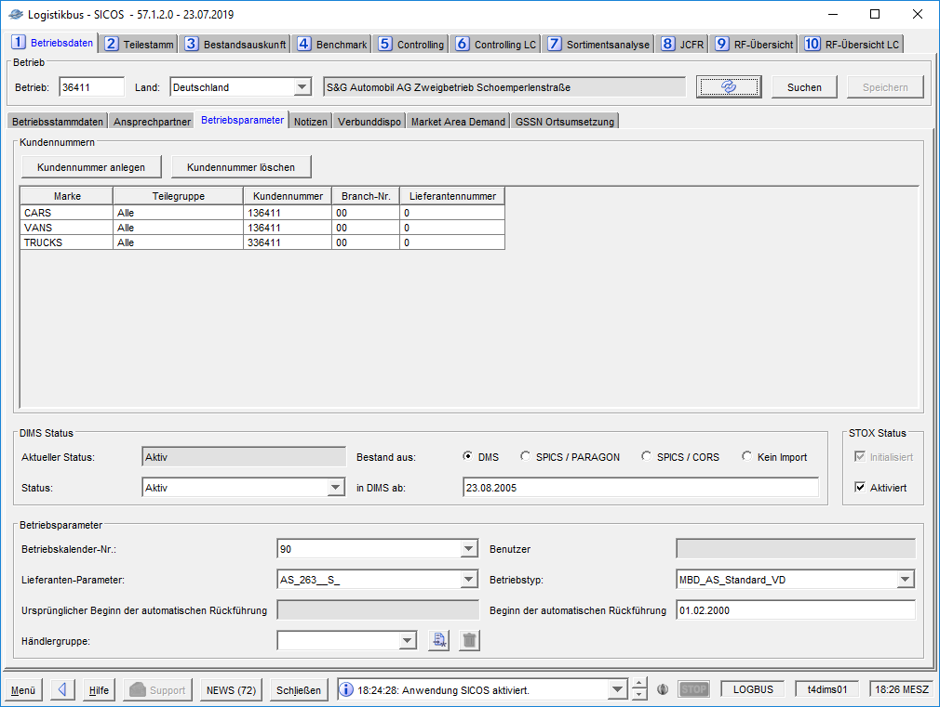

## Dealer Search

A dealer can be searched by the search criteria dealer number, dealer name, postal code, and area code. The criteria can be combined (e.g., all German dealer having "Karlsruhe" in the name can be searched). A list displays all dealer that match the search criteria. If a dealer is selected from the list and confirmed with "OK", the dialog box is closed, and the dealer data is loaded. “Cancel" closes the dialog box without further action.

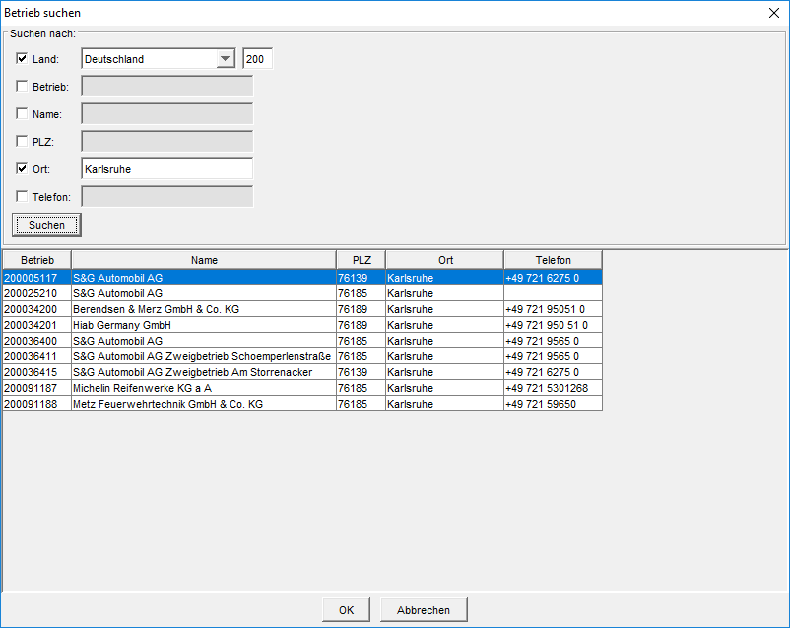

Figures 2-: Search Dealers

## Copying and creating new dealers

First, the new dealer number and the country code of the new dealer are searched and checked. If this dealer does not yet exist in the Dealer Data table but is already listed in the GSSN, it can be created or copied. If the dealer already exists in the dealer data or is not yet listed in the GSSN, the user receives a corresponding message that the action is not possible.

When copying a dealer, a new dealer is created, and all settings of the already existing reference dealer are taken over or copied. These settings include the disposition and supplier parameters and the dealer calendar. At the same time, the activation date can be set. The reference dealer can be entered directly or searched via "Search" dialog box as described previously.

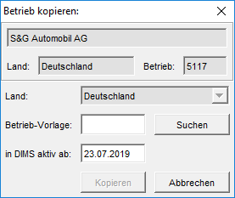

In addition to the dealer number, the dealer calendar, the Dispo parameter set, and the supplier parameter set are also searched in the new creation dialog. The parameter sets must already exist. Unlike copy function, the parameters of different dealers can serve as a template or can be set at a later time. If settings for the calendar and suppliers and Dispo parameters have been selected, the activation date can be set (disposition and order forwarding will be done from this date).

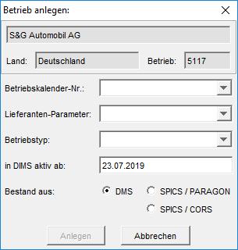

## Enhancements for Release 28

With Release 28, it will be possible to store a contact person for disposition in addition to the contact person for stock information. Similarly, a name, a telephone number, a fax number, and several e-mail addresses are to be recorded and maintained by the retail operation.



### Changes to the interface

Four new input fields are added to the user interface to display and enter this data. The fields are given the same label as the corresponding fields for the stock information contact person and are grouped by a box. The box is given the heading "contact person for Disposition". The existing fields for contact person for inventory information are reduced in size by half and placed on the left edge of the user interface. The new fields for contact person for disposition are placed to the right. Both fields are of the same size. The fields for the e-mail addresses have several lines. If the maximum number of displayable lines is exceeded by the content, vertical Scroll-Bars are displayed at the left edge, with which the content can be scrolled. If one of the fields Name, Phone, Fax, eMail (for contact persons for stock information or for disposition) is filled or changed, the button Save changes from inactive to active.

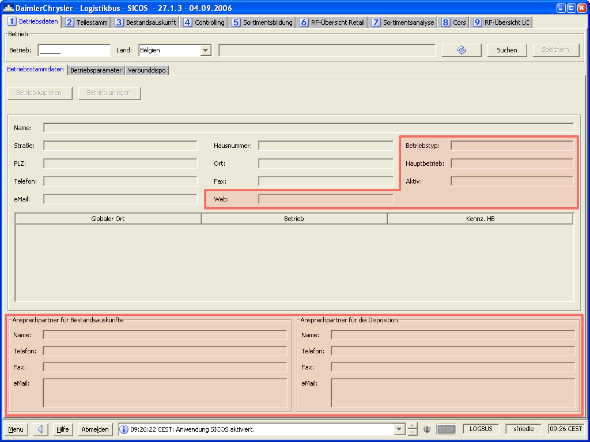

Figure 2‑2 - Screenshot Dealer Master Data

To create additional space on the user interface, the fields Dealer type, Main Dealer and Active are moved. Figure 2‑22 illustrates the new arrangement of the dealer master data. The changes/new features are marked in red.

### Permissions

Similar to the rights to change the contact persons for inventory information, the following user groups have the right to change the contact persons for disposition:

* Dispatcher
* Admin Controller

An admin controller can only change the contact persons of his authorized sites. An admin controller can change the contact persons of all locations.

### Entering E-mail addresses

The e-mail addresses field of the contact persons for inventory information is evaluated by certain logistics bus modules and used to send e-mails. At the time of this concept it is the return/stok analysis module. In the future, these modules should no longer use the e-mail addresses of the contact persons for inventory information, instead use those of the contact persons for disposition.

To allow the input of multiple e-mail addresses in one text field, the character # (hashtag) has been used as separator of the e-mail addresses so far. In the future, the characters , (comma), ; (semicolon) and whitespace (space, tab, line break) will also be used as separators to increase the readability of the e-mail addresses. The # (hashtag) character is kept for compatibility reasons. The following regular expression specifies the allowed separators for E-mail addresses: \s*[#,;\s]+ \s*

### Database extension

In order to save four new fields, the table BETRIEBSDATEN_KONZERN is extended by the following four fields:

|  |  |  |  |
| --- | --- | --- | --- |
| Column name | Type | Key | Description |
| **NAME_DISPO** | VARCHAR2(100) |  | Name of the responsible dispatcher |
| **EMAIL_ DISPO** | VARCHAR2(400) |  | Email of the responsible dispatcher |
| **TELEFON_ DISPO** | VARCHAR2(100) |  | Tel. of the responsible dispatcher |
| **FAX_ DISPO** | VARCHAR2(100) |  | Fax of the responsible dispatcher |

The fields for the name, the phone number and the fax number are of type VARCHAR2(100). Thus 100 characters can be entered. The field for the e-mail addresses is of type VARCHAR2(400), so 400 characters can be entered. The field EMAIL_BM (E-mail address(es) of the contact person for inventory information) currently has the type VARCHAR2(100). This field will be extended to 400 possible characters in the same way as the new E-mail field.

### Modifying dependent modules

Due to the extension of the E-mail separators, the splitting of the E-mail addresses must be modified in the module Return/Stockt Analysis. The regular expression described above must be used for this purpose.

Modification must be made for the Renumbering module, so that while renumbering (type U) and separating (type T), the new fields are also processed.

### Initial filling

The new fields are filled with the values of the inventory information fields via an SQL script:

UPDATE BETRIEBSDATEN_KONZERN   
 SET NAME_DISPO = NAME_BM,   
 EMAIL_DISPO = EMAIL_BM,   
 TELEFON_DISPO = TELEFON_BM,   
 FAX_DISPO = FAX_BM

## Enhancement for Release 31

**Panel 1 - Dealer Data**

In case of changes within the panel "Dealer Data" (in each of the three subpanels), a user who has the appropriate rights must be prompted for saving after his new entries or changes within the panels, when he switches between the subpanels, leaves the panel or the application (i.e. SICOS).

The prompt should be in the form of a hint message that forces the user to click on one of three buttons (YES/NO/cancel).

YES New entry/change is accepted and possible jump to a new panel or application

NO New entry/change is not accepted, and panel jumps back to status before the change or to a new panel or application.

Cancel New entry/change stops, jump to another panel or application is not possible.

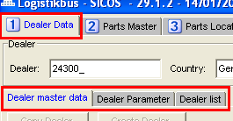 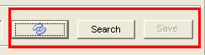

Problem: Currently (state R29) a user can leave the panel after a new entry or change without saving, which means that the changes are not applied.

**1.1. Subregister "Dealer Parameters”**

There is a possibility to create customer numbers for a location in the panel.

For this purpose, the fields brand, customer no., branch no. and supplier no. must be filled in.

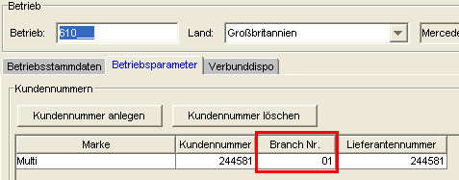

While all fields are OBLIGATORY fields, the Branch No. field, however, is NOT an OBLIGATORY field.

**Requirement:**

Like the remaining fields, the field "Branch No." should also be defined as a MUST field - i.e. an error message is to appear if the field is not filled (bug from ML implementation).

Extension by the part group to R47: The modification is described in section 2.10.

## Enhancement for Release 38



### DMS display in Dealer Data

In the dealer master data, both the DMS (Dealer Management System) and its version are displayed. For this purpose, 2 more fields are added, and the results table is extended by 2 columns.

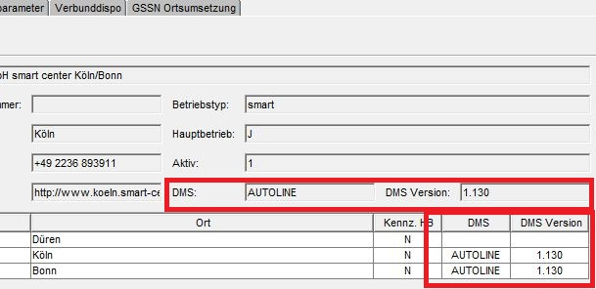

The changes are only visible for the centralist roles Central Controller, Market Controller, Central Controller and Admin Controller. For this purpose, 3 new resources are defined. These are shown in the following tables:

|  |  |  |  |  |  |  |  |  |
| --- | --- | --- | --- | --- | --- | --- | --- | --- |
| **SICOS** | **Inventory information** | **Controller** | **Dispatcher_X** | **Market controller** | **Central controller** | **Admin-controller** | **BA Controller** | **Central controller** |
| - Dealer master data 1 (BS1) | L | L | L, Ä (D) | L | L | Ä |  | L |
| + Dealer (BS1_BET) |  |  |  |  | Ä | Ä |  |  |
| + DMS (BS1_DMS) |  |  |  | L | L | L |  | L |

|  |  |  |  |  |  |  |
| --- | --- | --- | --- | --- | --- | --- |
| **CORS** | **Retailer1** | **Retailer2** | **RetailerLight** | **Market controller** | **Central controller** | **Admin Controller** |
| - Dealer master data 1 (BS1) | Ä (CORS) | Ä (CORS) | Ä (CORS) | L | L | Ä |
| + Dealer (BS1_BET) |  |  |  |  |  |  |
| + DMS (BS1_DMS) |  |  |  | L | L | L |

|  |  |  |  |  |
| --- | --- | --- | --- | --- |
| **STOX** | **RetailerDefault** | **RetailerAdmin** | **Market controller** | **Admin Controller** |
| - Dealermasterdata (DMD) | L | L | L | L |
| + ActivateStoxDealer (ASXD) |  |  |  | Ä |
| + ContactPerson (COPE) | L | L, Ä (DS), Ä(D2D) | L | Ä |
| + DMS (DMS) |  |  | L | L |

The DMS and DMS version are read from the fields DMS and DMS_VERSION of the table BETRIEBSDATEN_KONZERN. The values for these are updated automatically with each import.

## Extension for special patch 42.4.1.0



### New panel "Market Area Demand

Requirement:

In the Sicos panel "Dealer Data" a new subtab "Market Area Demand" is to be inserted after Verbunddispo

The layout of the new dialog is shown in Figure 2‑23 shown.

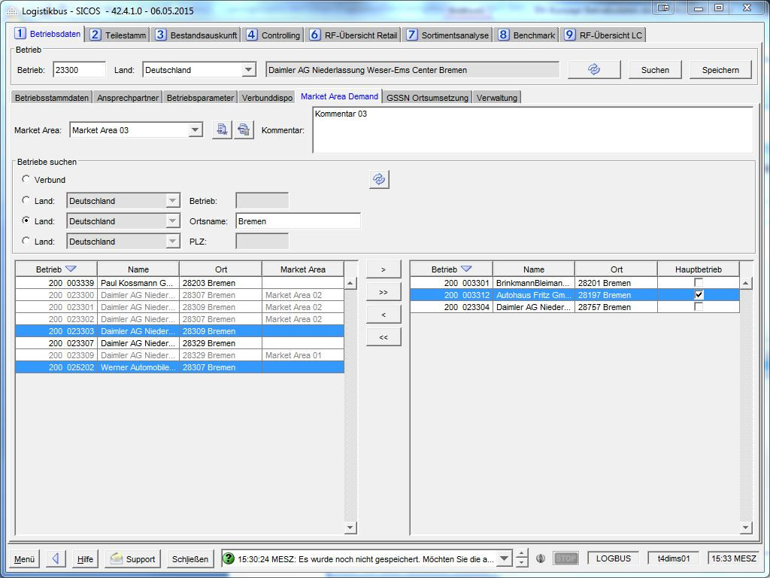

Figure 2‑3 - Panel Market Area Demand

Requirement:

When selecting the sub-tab "Market Area Demand", the header with the input fields "Betrieb" (Dealer) and "Land" (Country) as well as the "Laden" (Load) and "Suchen" (Search) buttons should be activated (similar to Verbunddispo (Intercompany Transfer)).

The "Speichern" (Save) button is initially greyed out and only becomes active when a change/modification is made (Similar to Verbunddispo(Intercompany Transfer)).

The "Land" (Country) combo-box in the SICOS main panel must be used to select a country for which the market areas are to be displayed or edited.

A Dealer must be entered via the "Dealer" input field.

When selected via the "Load" button, only the market areas are loaded,

* which are assigned to the country selected in header and
* which contain at least one dealer for which the user has at least read rights

If the dealer entered in the header is already included in a market area, clicking on "Load" will directly select the market area in which this dealer is located.

If no dealer or no valid dealer is entered, an error message appears.

If a dealer is entered for which the user does not have M.A.D. read rights, no data is loaded, and the panel remains empty and the controls are disabled. Since the header is shared by several dealer master data sub-panels, an error message will only appear if there is no read permission for any of these panels.

Similar to Verbunddispo (Intercompany Transfer), all eligible countries are included in the SICOS main panel country combo box. In principle, market areas can also be created for countries for which M.A.D. is not activated (but the M.A.D. calculation in the Dispo does not yet apply).

Requirement:

There should be four areas on the new panel (Similar to dealer list dialog):

1. The header area where market areas can be loaded, created and deleted. Additionally, a comment field where a note about the selected market area can be entered.
2. The search area where specific search criteria for dealers can be selected. The new panel shall use the same search functionality as the "Verbunddispo (Intercompany Transfer)" panel. This also means that the country combo boxes of the search can be pre-set with the country selected in the header and cannot be changed.

The only difference to the Verbunddispo (Intercompany Transfer) search:

In the "Verbund" (Network) search, the complete network is displayed, including the dealer entered in the header line.

1. The search results table on the left-hand side, in which the dealers matching the search criteria are listed. For each dealer, its market area is also displayed in an additional column, if this dealer already belongs to another market area.
2. A Market Area Participants table on the right side of the page listing all dealers in the currently selected Market Area.

Requirement:

Like the dealer list dialog, it should be possible to move dealers from the search results table to the market area participant table and vice versa.

Requirement:

It must be ensured that an operation may only be assigned to exactly one Market Area.

Dealers that are already assigned to a market area should be displayed in grey in the search results table. They cannot be selected and thus cannot be moved to another Market Area.

Requirement:

Dealers which are not stored in the user authorization PlacesDispositions (see REQ-RIGHT-1), should also be displayed with grey font in the search result table. They cannot be selected in the search result table and thus cannot be moved to a market area.

Requirement:

There must always be exactly one main dealer in a market area.

* The Main dealer column in the market area participant table must always contain exactly one check mark (if the table is not empty). The check whether a check mark is set is performed when "Save" is clicked. If no main dealercheck mark is set, an error message appears.
* If the user sets the main dealer checkmark for a dealer, the checkmark for the previous main dealer is automatically removed.
* If the main dealer is removed from the market area, the main dealer checkmark is not automatically passed to another dealer. The user must actively select a new main operation.

Note: In case of renumbering (merging), the department must ensure that the dealer to be changed (old GORT) is not a M.A.D. main dealer.

Requirement:

If there are unsaved changes, a prompt appears when you switch applications, panels or subpanels, or when you exit Logistiksbus, asking whether you want to save the changes.

Requirement:

When saving the dialog data, it should be checked which changes have been made to the composition of the M.A.D. network and, if necessary, the defined follow-up actions should be triggered. These are described in the document ***DV-Concept Market Area Demand -*** *Chapter 3.7 Composition of the M.A.D. network*.

### Authorization concept M.A.D.

Requirement:

Maintenance of the M.A.D. association in the Market Area Demand panel (see chap. 2.8.1) shall only be allowed for the following roles:

* Central controller
* Market controller
* Market Admin
* Admin Controller

For other roles, the dialog should be read-only.

The new authorizations are shown in Table 2‑21: Changes in the BerechtigungsmatrixTabelle 2‑21 shown (highlighted in yellow).

In the course of this further development, changes are also to be made to existing authorizations (highlighted in orange).

Remark:

Here it was originally planned to change further authorizations from L to L(C). However, since the authorization check goes to the header shared by the dealer data panels, this can only be implemented with additional programming effort.

|  |  |  |  |  |  |  |  |  |
| --- | --- | --- | --- | --- | --- | --- | --- | --- |
|  | **Inventory information** | **Controller** | **Disponent_X** | **Market controller** | **Central controller** | **Admin Controller** | **Marketadmin-controller** | **Central controller** |
| **SICOS (SIC)** (Inventory Information & Controlling System) |  |  |  |  |  |  |  |  |
| - Dealer master data 1 (BS1) | L | L | L, Ä (D) | L | L | Ä | L (C), Ä (D) | L |
| + Dealer (BS1_BET) |  |  |  |  | Ä | Ä | Ä (D) |  |
| + DMS (BS1_DMS) |  |  |  | L | L | L | L | L |
| - Dealer master data 2 (BS2) |  | L | L | L | Ä | Ä | L (C), Ä (D) | L |
| + customer numbers (BS2_KNU) |  |  |  | Ä (D) | Ä | Ä | Ä (D) | L |
| + Dealer (BS2_BET) |  |  |  |  | Ä | Ä | Ä (D) |  |
| - Dealer master data 3 (BS3) *(Verbunddispo)* |  |  | L, Ä (D) | L | Ä | Ä | L (C), Ä (D) | L |
| + Free deal search (BS3_FBS) |  |  |  |  | L | L | L (C) |  |
| - Dealer Master Data 4 (BS4) *(GSSN Conversion)* |  |  |  | L (C), Ä (D) | Ä | Ä | L (C), Ä (D) | L |
| - Dealer Master Data 6 (BS6) *(Market Area Demand)* |  |  | L (C) | L (C), Ä (D) | Ä | Ä | L (C), Ä (D) | L( C) |
| + Free dealer search (BS6_FBS) |  |  |  | L(C) | L | L | L (C) |  |

Table 2‑1: Changes in the authorization matrix

## Enhancement for Release 43



### New subpanel "Notes“

The subpanel "Notes" is used to record additional information about a dealer (e.g., recording of information by logistics consultants, notes on peculiar dealers, ...).

A note is made up of the following components:

* The dealer to which the note is linked
* The date when the note was created or updated
* The note itself as a comment
* The user ID of the one who created the note
* The application in which the note was created
* (optional) file attachments to the note
* (optional) a resubmission date for the note

The panel is to be used in the CORS, STOX and SICOS applications, whereby it will be embedded in the operating data in STOX and SICOS (STOX: after contact person SICOS: between dealer parameters and Verbunddispo(Intercompany Transfer)) and in CORS in the "3 Clearing" panel.

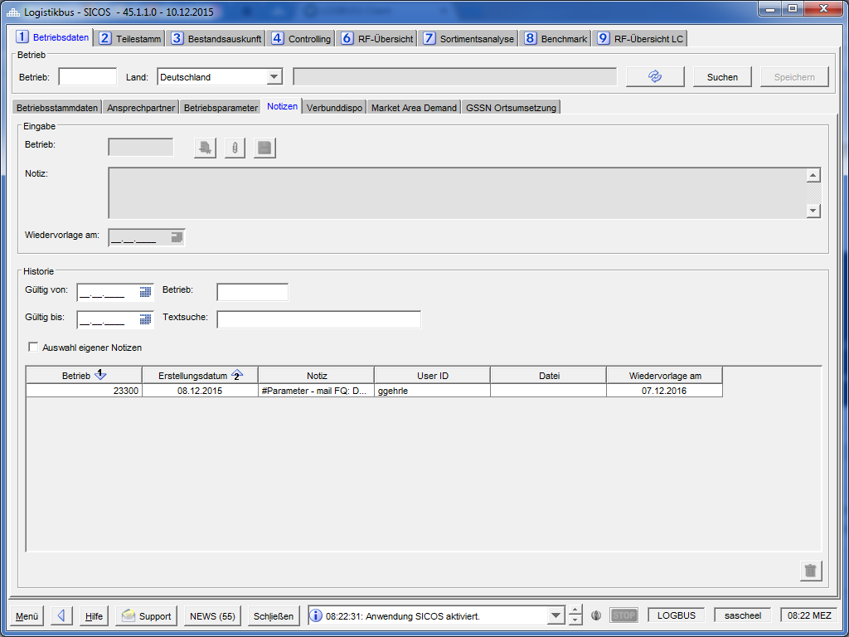

Figure 2‑4: Subpanel notes

The panel is divided into two sections. The "Input" section is used to create or edit notes. The "History" section is used to view notes that have already been created. Both sub-fields are described in more detail below.

All GUI elements described are assigned with tooltips.

#### Input section

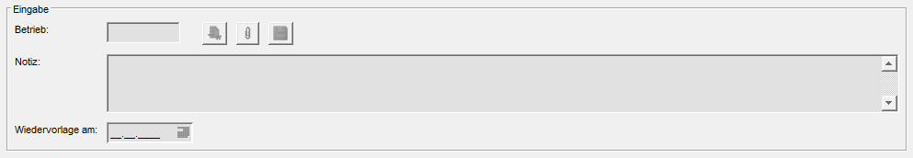

Figure 2‑5: Notes subpanel "Input" section

In this section:

* new notes are created and saved,
* saved notes can be edited,
* saved notes can be viewed.

The section is active only when an operation is loaded in the main panel.

The **Dealer** field is used to display the dealer that is currently being edited.

After loading an individual dealer, the field contains its dealer number. If an already created note is loaded into the input area, then the dealer belonging to the note is displayed in this field. Otherwise, the field is empty.

The field is always inactive. It is only used for display.

The **Note** field is used to enter a new note or to display a saved one. The field is limited to 1000 characters.

The field is mandatory.

The field is active when:

* a new note is created
* the current user is the creator of a note that is currently displayed in the "Input" section.

Otherwise, the field is inactive and cannot be edited.

The **Resubmission on** field is used to enter a date when the creator wants to be reminded of this note. No dates in the past can be entered in the field. Moreover, the field can only contain dates that actually exist (e.g. not 30.02.xxxx).

The input can be entered via the calendar menu or manually.

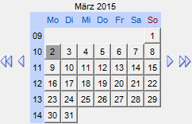

Figure 2‑6: Calendar menu

If an invalid value is entered (e.g., 30.02.2015), then this value will be corrected to a valid date (e.g., 02.03.2015) when the field is exited.

The field is not mandatory.

The field is active when:

* a new note is created,
* the current user is the creator of a note that is currently displayed in the "Input" area.

Otherwise, the field is inactive and cannot be edited.

**The New (Neu)** button (an empty sheet with an asterisk in the bottom right corner) causes the Note and Resubmission fields to be cleared. A new note can be created. If the Resubmission and Note fields are filled with unsaved values, a query will first appear asking whether the values should be saved.

When you click on the **Save (Speichern)** button (a disk symbol), the system first checks whether all mandatory fields (site and note) have been filled in.

If all mandatory fields are not filled, a corresponding message is displayed which must be confirmed with "Ok". It will not be saved.

If all mandatory fields are filled, a created or changed note is saved. The fields "Dealer", "Note", "Resubmission on", the creator of the note, the active application and the modification date (the time of saving) are written or updated in the database. The saved note is still displayed and added to the history.

The button is active only if there are unsaved changes. Otherwise, it is greyed out.

The history is not automatically reloaded after saving a note. This means that notes from other users are not immediately displayed in the history table.

The **File Clipboard (Dateiablage)** button (marked by a paper clip) opens a dialog for managing files to be attached to a note.

The button will be activated as soon as all mandatory fields for a note (dealer and comment) are filled.

The dialog box is described in chapter 2.9.1.1.1.

##### File overview dialog box

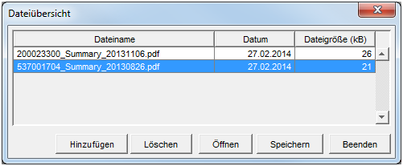

Figure 2‑7: File management dialog

The dialog box contains a table that displays the added files and buttons for adding, deleting, opening and saving files. In addition, the dialog box has a button to exit the dialog box. In the following, the functionality of the file overview panel will be explained.

The table contains all selected files that are assigned to a note. Multiple selections are possible. In addition, the table can be sorted by all columns. By default, the attachments with the most recent date are displayed first.

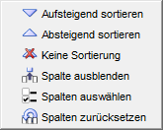

Figure 2‑8: Context menu of the table

Clicking the "**Add**" button opens a file selection dialog box.

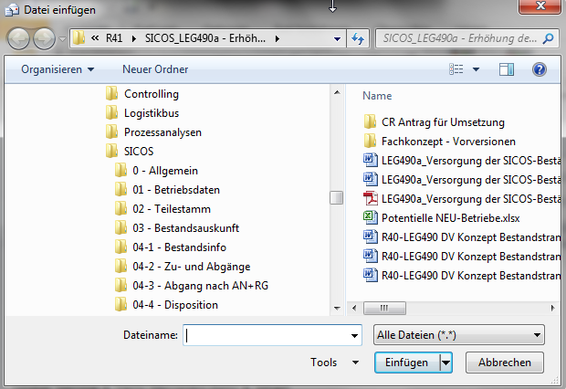

Figure 2‑9: File selection dialog box

File formats will be limited to Word (.doc, .docx), PDF, Excel(.xls, .xlsx, xlsm) and JP(E)G files. The maximum file size is 4 MB. The maximum length of the file name is 100 characters.

Files that do not meet the specified criteria are not listed in the selection dialog.

After inserting a file, you return to the file overview dialog box in which the previously selected file is displayed.

An already attached file cannot be added twice/multiple times to the same note.

When clicking on the "**Delete**" (**Löschen**) button, a query is first displayed asking whether the selected files should be deleted. The query can be acknowledged with "Yes" or "No".

If the query is answered with "Yes", all marked entries of the table are deleted.

If the query is answered with "No", no action is performed.

Clicking the "**Open**" (**Öffnen**) button will open all the marked files.

When you click on the "**Save**" (**Speichern**) button, the system first checks whether the created note, to which the specified files are to be linked, has already been saved. If this is not the case, a message is displayed that both the note and the files will be saved. The message can be acknowledged with "OK" and "Cancel". In case of "OK" the files including the created note are saved and the file overview dialog box closes. In case of "Cancel" you return to the file overview dialog box and the changes are not saved.

If the associated note is already saved when the "Save" button is clicked, the files are saved without prompting, linked to the note and the file overview dialog box closes.

When you click on the "**Exit**" (**Beenden**) button, the system first checks whether there are any unsaved changes. In this case, a message is displayed that there are unsaved changes and you are asked whether these should be saved. It is possible to acknowledge the query with "Yes", "No" and "Cancel".

In case of "Yes" the files including the created note (if it has not been saved yet) will be saved and the file overview dialog closes.

In case of "No" the file overview dialog closes and the added files are not saved.

In case of "Cancel" nothing is saved and you return to the file overview dialog.

If there are no unsaved changes when you click "Exit", the file overview dialog closes.

The "Add", "Save" and "Delete" buttons are only displayed if a new note is created OR the current user is the creator of a note that is currently displayed in the "Input" section.

Otherwise, the buttons will not be displayed.

The actions in the file overview dialog box have no influence on the modification or creation date of the note.

#### History section

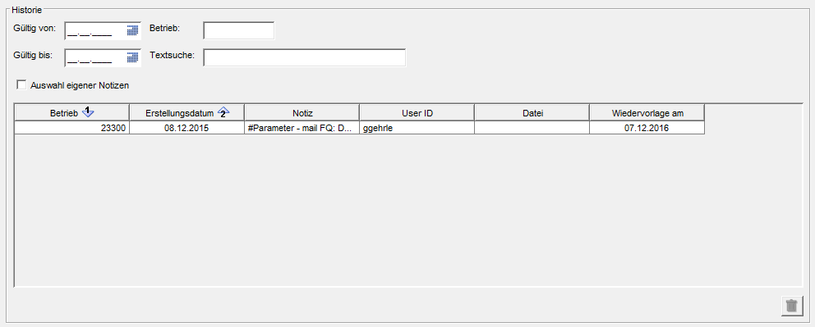

Figure 2‑10: Subpanel note subsection "History

In this section, created notes can be viewed, filtered and deleted.

The area is always active.

##### The results table

The **results table** shows the history of the currently loaded dealer. If no dealer is specified in the panel header, the table shows the history of all dealers of the country selected in the panel header. If no dealer is entered, no error message will be displayed.

The table consists of the following columns:

* Dealer
  + The dealer for which the note was entered is displayed here
* Date
  + The date when the note was created is displayed here (no modification date)
* Note
  + Here the note, shortened to the width of the column, is displayed
* User ID
  + The user ID of the note creator is displayed here
* File
  + If files are stored for a note, a paper clip symbol is displayed here
* Resubmission on
  + The date for which the creator has stored a reminder for resubmission is displayed here (not a mandatory field).

When you click on a row in the results table, the record is displayed in the upper input section.

If you are the creator, you can edit the note. Otherwise, all input fields (note and resubmission date) remain inactive.

Double-clicking on a paper clip symbol in the "File" column opens the file overview dialog box. The functions of the dialog box are described in chapter 2.9.1.1.1.

The table has the usual table functions (see Figure 2‑211).

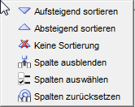

Figure 2‑11: Table functions

Additionally, multiple sorting by different columns is possible.

If nothing else is selected, the table is sorted by default by dealer number (ascending) and date (descending).

Only one row in the table can be marked at a time. Multiple selections are not possible.

##### Filter

The items in the results table can be filtered. The filter functions are explained below:

If a date is specified in the "**Valid from**" (**Gültig von**) filter, then only those items in the table whose creation date is equal to or greater than the specified date will be displayed during the next loading process. Date can be entered either directly via the input field or also via the calendar function. Invalid manual entries are automatically changed to the next possible valid date.

If a date is specified in the "**Valid to**" (**Gültig bis**) filter, then only those items in the table whose creation date is equal to or less than the specified date will be displayed during the next loading process. The date can be entered either directly via the input field or also via the calendar function. Invalid manual entries are automatically changed to the next possible valid date.

If a value is specified in the "**Dealer**" (**Betrieb**) filter, then the next loading process will display only those items in the table whose assigned dealer number, with the entered search value corresponds.

If a value is specified in the "**Text search**" (**Textsuche**) filter, then only the items in the table whose comment contains the search text will be displayed during the next loading process. The upper or lower case does not matter.

If the "**Selection of own notes**" (**Auswahl** **eigener Notizen**) checkbox is selected, then the items in the table that were created and saved by the logged-in user will be displayed during the next loading process.

The filter functions can be combined with each other. In doing so, the criteria are AND-linked.

Ex: Text search for "Hello" and "Valid from" set to 01.01.2014

All notes are searched that were created since 01.01.2014 and contain the word "Hello". With the exception of the filter "Selection of own notes", it is sufficient to press the ENTER key after entering one of the filters in order to update the display in the history table accordingly.

##### Delete function

When you click on the "**Delete**" button (a trash can icon), a query first appears asking whether the selected line should actually be deleted.

If the query is confirmed with "Yes", the selected line is deleted.

If the query is confirmed with "No", the selected line will not be deleted.

Only notes that the user has created can be deleted.

The Delete button is active only if a note created by the current user is selected, otherwise it remains inactive.

#### Unsaved changes

If there are unsaved changes within the panel, then a query appears for subsequent actions asking whether the unsaved changes should be saved:

* Loading a dealer
* Changing the subpanel
* Changing the main panel
* Changing an application
* Exiting the application

If the query is answered with "Yes", the changes are saved, and the selected action is executed.

If the query is answered with "No", the changes are not saved, and the selected action is executed.

If the query is answered with "Cancel", the changes are not saved, and the selected action is not executed.

#### Notification on the resubmission date

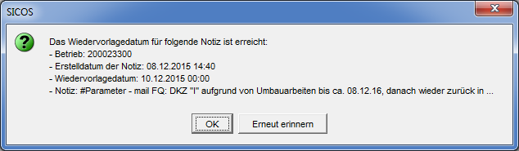

Figure 2‑12: Notification on the resubmission date

If the following criteria are met, a notification is displayed when the application starts up:

* the user is the creator of the note
* the currently selected application is the same as the application in which the note was created
* the resubmission date has been reached or exceeded
* the user has not confirmed the resubmission yet

The notification contains the following data:

* the dealer for which the note was created
* the creation date of the note
* the resubmission date of the note
* the note or an excerpt of it if the text is too long

The notification can be acknowledged with "OK" or "Remind again".

Clicking on "OK" closes the notification. In addition, the information that the user has received the notification and acknowledged it with "OK" is stored in the database.

When clicking on "remind again", the user will be reminded of this note again the next time the application is booted.

One notification is displayed per note. This means that if several notes are placed on resubmission for one day, then a notification is displayed for each individual note when the application is booted.

#### Database change

Two new tables are needed to store notes and their associated attachments.

**DEALER_NOTES Table**

|  |  |  |  |
| --- | --- | --- | --- |
| **Column Name** | **Data Type** | **Not zero?** | **Comments** |
| **DN_ISN** | NUMBER(14) | Y | Unique ISN |
| **DN_DEALER_NUMBER** | NUMBER(9) | Y | Dealer number |
| **DN_APPLICATION** | VARCHAR2(20 CHAR) | Y | Application in which the note was created (STOX,SICOS,CORS) |
| **DN_COMMENT** | VARCHAR2(300 CHAR) | Y | Comment text of the note |
| **DN_NOTIFICATION_DATE** | Date |  | Resubmission date |
| **DN_USER_ID** | VARCHAR2(9 CHAR) | Y | User ID of the creator |
| **DN_CHANGE_DATE** | Date |  | Modification date |
| **DN_NOTIFICATION_ACCEPTED** | VARCHAR2(1 CHAR) | Y | Flag whether notification should be displayed again at next startup |
| **DN_FILE_COUNT** | NUMBER(3) | Y | Number of attached files |

Table ‑: DEALER_NOTES table

**DEALER_NOTES_FILES Table**

|  |  |  |  |
| --- | --- | --- | --- |
| **Column Name** | **Data Type** | **Not zero?** | **Comments** |
| **DNF_ISN** | NUMBER(14) | Y | Unique ISN |
| **DNF_DN_ISN** | NUMBER(14) | Y | Unique ISN of the associated note |
| **DNF_FILE_NAME** | VARCHAR2(100 CHAR) | Y | File name |
| **DNF_FILE_CONTENT** | BLOB |  | File content |
| **DNF_FILE_SIZE** | NUMBER(14) | Y | File size |
| **DNF_UPLOAD_DATE** | Date |  | Upload date |

Table ‑: DEALER_NOTES_FILES

#### Permissions

New resources for STOX, SICOS and CORS are created for the visibility of the panel.

In the SICOS application, the Admin, Market Admin and Central Controller roles are allowed to use the Notes panel restricted to the OrteDisposition list.

|  |  |  |  |  |  |  |  |  |
| --- | --- | --- | --- | --- | --- | --- | --- | --- |
|  | **Inventory information** | **Controller** | **Dispatcher_X** | **Market controller** | **Central controller** | **Admin Controller** | **Market Admin** | **Central controller** |
| **SICOS (SIC)** (Inventory Information & Controlling System) |  |  |  |  |  |  |  |  |
| - Dealer master data 1 (BS1) | L | L | L, Ä (D) | L | L | Ä | L (C), Ä (D) | L |
| + Dealer (BS1_BET) |  |  |  |  | Ä | Ä | Ä (D) |  |
| + DMS (BS1_DMS) |  |  |  | L | L | L | L | L |
| - Dealer master data 2 (BS2) |  | L | L | L | Ä | Ä | L (C), Ä (D) | L |
| + customer numbers (BS2_KNU) |  |  |  | Ä | Ä | Ä | Ä (D) | L |
| + Dealer (BS2_BET) |  |  |  |  | Ä | Ä | Ä (D) |  |
| - Dealer master data 3 (BS3) *(Verbunddispo)* |  |  | L, Ä (D) | L | Ä | Ä | L (C), Ä (D) | L |
| + Free dealer search (BS3_FBS) |  |  |  | L | L | L | L (C) | L |
| - Dealer Master Data 4 (BS4) *(GSSN Conversion)* |  |  |  | L (C), Ä (D) | Ä | Ä | L (C), Ä (D) | L |
| - Dealer master data 5 (BS5) *(note panel)* |  |  |  | Ä(D) | Ä(D) | Ä(D) | Ä(D) |  |
| - Scrapping parameters (VSP) |  |  | Ä (D) | Ä (D) | Ä | Ä | Ä (D) | Ä (D) |
| + Scrapping Algorithm Online (VSP_VON) |  |  |  |  |  | Ä | Ä (D) |  |
| - Total scrapping overview (VGU) |  |  | Ä (D) | Ä (D) | Ä | Ä | Ä (D) | Ä (D) |
| + Scrapping file creation (VGU_VDE) |  |  | Ä (D) |  |  |  |  |  |
| - Scrapping unit overview (VEU) |  |  | Ä (D) | Ä (D) | Ä | Ä | Ä (D) | Ä (D) |
| - Overview return LC (ULC) |  |  |  | L (C) | L | L | L (C) | L (C) |
| - Overview return dealers (UHA) |  | L (C) | Ä (D) | L (C) | L | L | L (C) | L (C) |
| - Benchmark (BEN) |  | L (C) | L (C) | L (C) | L | L | L (C) | L (C) |
| - Key figures DIMS service level (KDS) |  |  |  | L | L | L | L | L |

In the STOX application, the Admin and Market Controller roles are allowed to use the Notes panel restricted to the OrteDS or OrteD2D list.

|  |  |  |  |  |
| --- | --- | --- | --- | --- |
|  | **RetailerDefault** | **RetailerAdmin** | **Market controller** | **Admin Controller** |
| **STOX (SX)** |  |  |  |  |
| - Dealermasterdata (DMD) | L | L | L | L |
| + ActivateStoxDealer (ASXD) |  |  |  | Ä |
| + ContactPerson (COPE) | L | L, Ä (DS), Ä(D2D) | L | Ä |
| + DMS (DMS) |  |  | L | L |
| + Notes (NOTE) |  |  | Ä (DS), Ä(D2D) | Ä (DS), Ä(D2D) |

In the CORS application, the Admin and Central Controller roles are allowed to use the Notes panel restricted to the OrteCORS list.

|  |  |  |  |  |  |  |
| --- | --- | --- | --- | --- | --- | --- |
|  | **Direct customer** | **Retailer2** | **RetailerLight** | **Market controller** | **Central controller** | **Admin Controller** |
| **CORS (COR)** |  |  |  |  |  |  |
| - Exchange returns (TAUSCH) | Ä (CORS) | Ä (CORS) | Ä (CORS) | L (CORS) | L (CORS) | Ä |
| - Delete transfer quantity (LOE_TRAN) |  |  |  |  | Ä | Ä |
| - Upload inventory data (LAD_BEST) | Ä (CORS) |  | Ä (CORS) |  |  | Ä |
| - Exchange parts reference transfer (TRANSFER) |  | Ä (CORS) | Ä (CORS) | Ä (CORS) | Ä (CORS) | Ä |
| - Repco input (REPCO) |  | Ä (CORS) | Ä (CORS) | Ä (CORS) | Ä (CORS) | Ä |
| - Business progreaa (G_VERL) | L (CORS) | L (CORS) | L (CORS) | L (CORS) | L (CORS) | Ä |
| + Edit files (EDIT_FILES) |  |  |  |  | Ä (CORS) | Ä |
| + Search for RWL/RMA (RMA_SEAR) |  |  |  | L | L | L |
| + Eligibility Transfer Display (ET_VIEW) |  |  |  |  | L | L |
| - Unequal exchange (UNGL_TAU) |  |  |  |  | Ä (CORS) | Ä |
| - Excess stock (UEB_BEST) |  |  |  |  | Ä (CORS) | Ä |
| - Controlling (CONTR) | L (CORS) | L (CORS) | L (CORS) | L (CORS) | L (CORS) | L |
| + LC land controlling (CTRL_LC) |  |  |  | L (CORS) | L (CORS) | L |
| + Unequal exchange (CTRL_US) |  |  |  | L (CORS) | L (CORS) | L |
| - Dealer master data 1 (BS1) | Ä (CORS) | Ä (CORS) | Ä (CORS) | Ä (CORS) | L | Ä |
| + Dealer (BS1_BET) |  |  |  |  |  |  |
| + DMS (BS1_DMS) |  |  |  | L | L | L |
| - Dealer master data 2 (BS2) |  |  |  | L | L | L |
| + customer numbers (BS2_KNU) |  |  |  | L | L | L |
| + Dealer (BS2_BET) |  |  |  | L | L | L |
| - Operational master data 3 (BS3) *(Verbunddispo)* |  |  |  |  |  |  |
| + Free dealer search (BS3_FBS) |  |  |  |  |  |  |
| - Dealer Master Data 4 (BS4) *(GSSN Conversion)* |  |  |  | Ä (CORS) | Ä (CORS) | Ä |
| - Dealer master data 5 (BS5) *(CORS site management)* |  |  |  |  |  | Ä |
| - Dealer master data 6 (BS6) *(note panel)* |  |  |  |  | Ä(CORS) | Ä(CORS) |
| - Inventory information CORS (BIN_CORS) |  |  |  |  | Ä (CORS) | Ä |
| - News (USR_MSG) | L(C) | L(C) | L(C) | Ä(C) | Ä(C) | Ä |
| - License texts (LIZ) |  |  |  | L | Ä | Ä |

## Enhancements for Release 47 - "Dealer parameters" panel

Requirement:

Customer number mapping is to be extended to allow mapping at the part group level.

For this purpose, a new column "Parts group" is to be added to the table " KUNDEN_NUMMERN". The default entry should be 0 (All parts groups). This way existing mappings remain valid.

The table in the "dealer parameters" panel should provide all available parts groups for selection (Combo box).

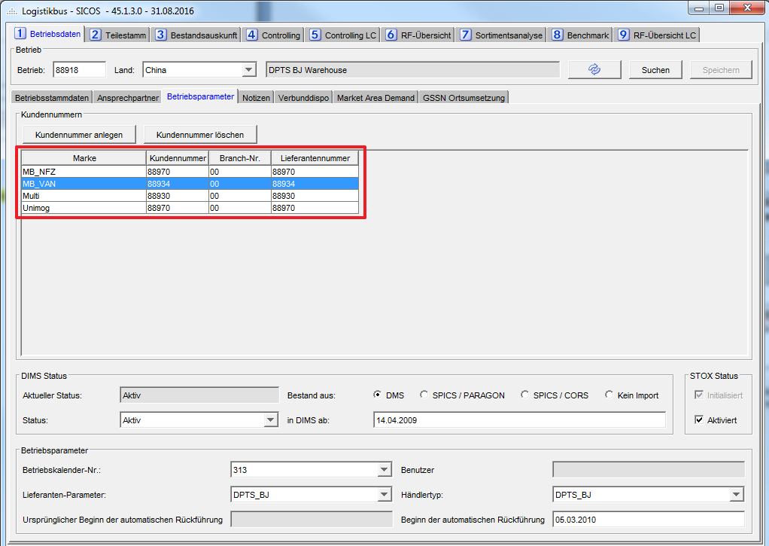

## Enhancements for Release 50



### Contact person 1st level support

Requirement:

Two additional sections for maintaining contacts are added to the Contact person tab:

* 1st level support DIMS / SICOS / SystemControl
* 1st level support STOX

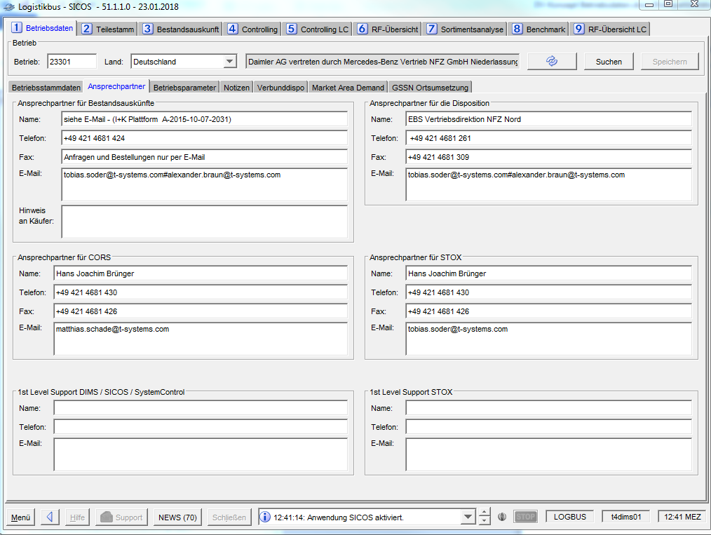

Figure 2‑13 Contact person 1st level support screen

Requirement:

The following contact data can be maintained for the new contact persons (Like the previous ones):

* Name: max. 99 characters
* Phone: max. 99 characters
* E-mail address: max. 399 characters

The plausibility check of the input is carried out in the same way as for the already existing contact persons.

Requirement:

The new contact persons are stored in the same way as the existing ones in the table BETRIEBS_KONTAKTE under the following new company contact types:

* Type 1st level DIMS / SICOS / SystemControl = 5
* Type 1st level STOX = 6

Requirement:

The new sections are only visible if the user is authorized for the respective applications (at least one from the DIMS / SICOS / SystemControl group).

Requirement:

In addition, the 1st level support STOX section is visible similar to the STOX contact person only if the user is authorized for the STOX application.

Requirement:

Write access is controlled via a new resource in the authorization concept:

|  |  |  |  |
| --- | --- | --- | --- |
| Resource | Market controller | Market Admin | Admin Controller |
| - Dealer master data 1 (BS1) | L | L(C), Ä(D) | Ä |
| + Dealer (BS1_BET) |  | Ä | Ä |
| + DMS (BS1_DMS) | L | L | L |
| + 1st level support (BS1_FLS) | Ä(D) | Ä(D) | Ä |

Table 2‑4: Authorization for 1st level support

All other roles have read access to the data of the new contact persons according to their rights in resource BS1.

Requirement:

The initial filling of the new contact persons is done by a script on the release date. The basis is the data of the contact persons per dealer, which must be provided by DAI in the form of an Excel file at least 2 weeks before the release date. The Excel file must contain the fields dealer (9-digit, mandatory field), name, telephone, and e-mail address. The e-mail addresses included will not be validated by T-Systems.

### Dealer parameter “Dealer group"

Requirement:

On the dealer parameters tab, a new parameter "Dealer group" is added to the dealer parameters section.

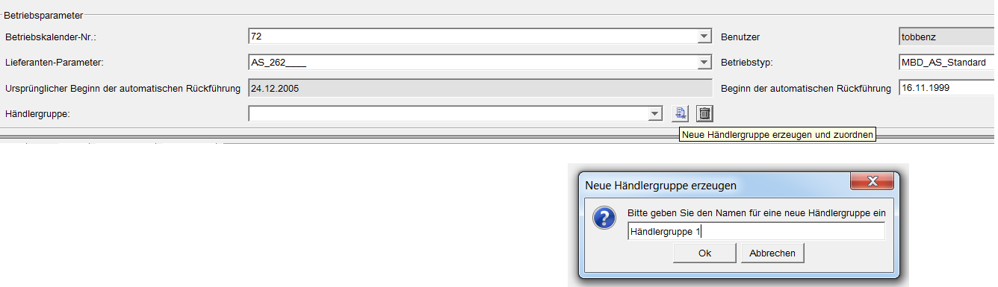

Figure 2‑14 Dealer parameters screen from the point of view of an Admin Controller: Creating a Dealer group

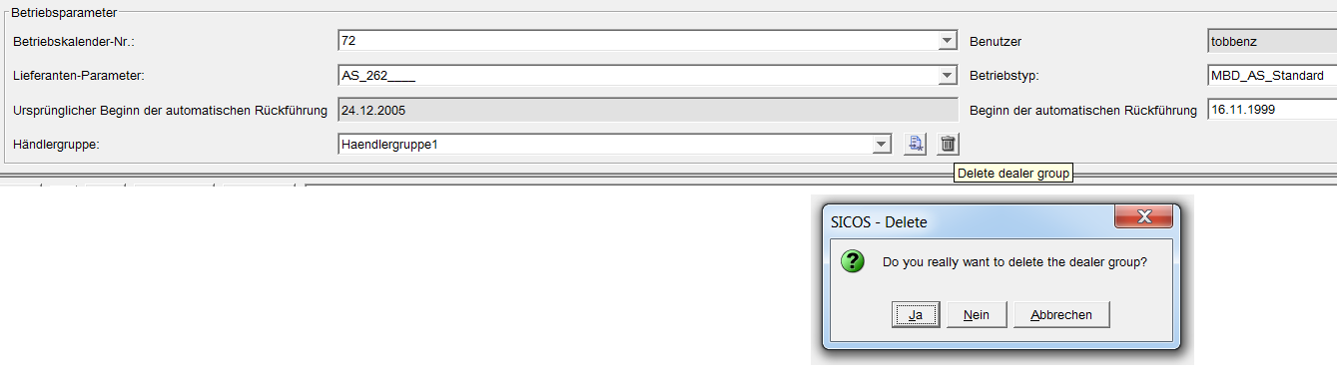

Figure 2‑15 Dealer parameters screen from the point of view of an Admin Controller: Delete Dealer Group

Requirement:

It is a combo box, an add button and a delete button. In the combo box, all values currently used for the country of the selected dealer are available for selection. If no values are assigned, the combo box is empty. The Add button can be used to assign a new dealer group to the selected company. The dealer group can be up to 50 characters long. The Delete button can be used to remove an existing dealer group from a dealer. Both buttons are assigned with tool tips.

Requirement:

The values in the combo box are updated whenever a dealer is loaded.

Requirement:

The dealer master data tab is extended to display the new dealer parameter Dealer group (i.e. no change option in this tab).

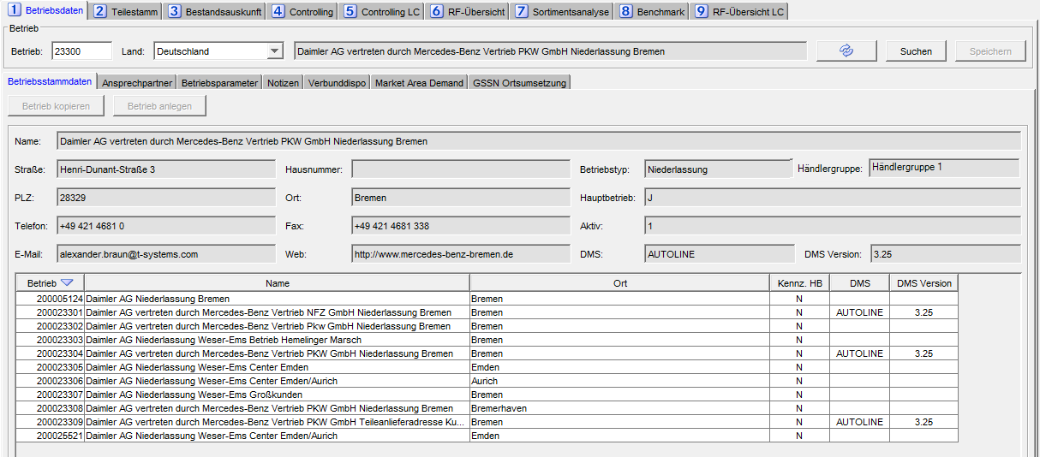

Figure 2‑16: Dealer data screen from a Controller's point of view

Requirement:

Read or write access in the tab Dealer master data and Dealer parameters is managed via a new resource in the authorization concept.

|  |  |  |  |  |
| --- | --- | --- | --- | --- |
| Resource | Market Controller | Central Controller | Market Admin | Admin-controller |
| - Dealer master data 2 (BS2) | L | Ä | L(C), Ä(D) | Ä |
| + customer numbers (BS2_KNU) | Ä(D) | Ä | Ä(D) | Ä |
| + Dealer (BS2_BET) |  | Ä | Ä(D) | Ä |
| + Dealer group (BS2_HGR) | L | L | Ä(D) | Ä |

Table 2‑5: Authorization for dealer parameters Dealer group

For all other roles, the field is not displayed in either tab.

Requirement:

The table DEALERDATA_GROUP is extended by one column:

|  |  |  |  |
| --- | --- | --- | --- |
| Database field | PK | Type | Description |
| HAENDLER_GRUPPE |  | VARCHAR2(50) | Dealer group |

Table 2‑6New dealer group field in the company data group table.

Requirement:

The initial filling of the new dealer parameter "Dealer group" is done by script on the release date. The basis is the data of the parameter per dealer, which must be provided by DAI in the form of an Excel file at least 2 weeks before the release date. The Excel file must contain the fields dealer (9-digit, mandatory field) and dealer group.

### Creation and parameterization of new dealers

For creating many new dealers (e.g., for creating a complete market as part of a WebParts rollout in a non-DIMS market), the options available till now (create or copy dealer) are not sufficient or involve considerable manual effort. For this reason, the "Dealer data" panel (subpanel "Dealer master data") provides the option of "mass creation" of dealer numbers and their dealer parameters.

Requirement:

The "Upload" button (to the right of "Create dealer") is added to the dealer master data tab. The button opens a file dialog for selecting an Excel file (formats "XLS" and "XLSX") for mass creation.

Requirement:

The first two sheets of the Excel file are imported. The two sheets contain all the necessary data for the dealer:

1. Dealer data and parameters: e.g., dealer number, calendar, dealer type, supplier parameters
2. Customer numbers

The order of the sheets is as above and cannot be changed. The file may contain dealers from different markets (countries)

The naming of the individual sheets is irrelevant.

If the Excel file has less than 2 sheets, it will be rejected. If it has more than 2 sheets, the extra sheets are ignored (not imported).

Requirement:

All two sheets of the Excel file have the following limitations:

* No header line is allowed. The data is already in the first line.
* Empty rows are ignored (not imported).
* The order of the individual fields is as specified in the definition and cannot be changed.
* The maximum number of dealers to be created (=number of non-empty rows in Sheet 1) is 500.

Requirement:

Sheet 1 consists of the dealer data and parameters. Each line consists of the following fields:

|  |  |  |
| --- | --- | --- |
| Field in Excel file | Column | Expression |
| Dealer number | 1 | 9-digit dealer number |
| GSSN outlet codes | 2 | Optional List of GSSN outlet codes (alphanumeric), if different from the local dealer number. Multiple codes (separated by semicolon) can be specified. The individual codes have a maximum of 8 digits. If not empty, the codes are transferred to the GSSN local conversion. |
| Calendar number | 3 | Order calendar number |
| Dealer type | 4 | Name of the dealer type (for Dispo parameters) |
| Supplier parameters | 5 | Name of the supplier parameter |
| Stock import | 6 | Indicator for stock import  D = DMS  S = SPICS / PARAGON  C = SPICS / CORS |
| DIMS active | 7 | Optional - Date "DIMS Status Active from" (dealer is created inactive if empty).  The date must be a valid Excel date format. |

2‑7 Formats of the individual columns for Sheet 1 (Dealer data)

|  |  |  |  |  |  |  |
| --- | --- | --- | --- | --- | --- | --- |
| 200123456 |  | 2 | MBD_NDL_Standard_VD | NDL_260___I | D | 17.05.2017 |
| 200234567 |  | 2 | MBD_NDL_Standard_VD | NDL_260___I | D |  |
| 200345678 | 345A; 345B | 2 | MBD_NDL_Standard_VD | NDL_260___I | D | 17.05.2017 |

2‑8 Example of the format of Sheet 1 of an Excel file

Requirement:

Sheet 2 consists of the customer numbers of the dealers (for the individual brands). The Excel sheet contains a separate row for each dealer, brand and parts group and consists of the following fields:

|  |  |  |
| --- | --- | --- |
| Field in Excel file | Column | Expression |
| Dealer number | 1 | 9-digit dealer number |
| Brand | 2 | The brand - valid values are:  EVOBUS  MAYBACH/SLR  MB_NFZ  MB_PKW  MB_VAN  MITSUBISHI  MULTI  NATIONAL  SMART  UNIMOG |
| Parts group | 3 | Max. 4-digit ID of the parts group  Currently valid values are (status R49):  0 = **Alle** 1001 = Altteil  1002 = Zubehör  1003 = Werkzeug  1004 = Diebstahlrelevant  1005 = Aggregat  1006 = B9  1007 = Kundendienst  1008 = Gefahrgut  1009 = begrenzte Lagerdauer  1010 = Q-Teile  1011 = ES1 26/27  1012 = Trailer Parts  1013 = Sperrigteil  1014 = Erstbevorratung  1015 = Räder/Reifen  1016 = Öle  1017 = Wartung/Verschleiß  1018 = Abweichender Bezug  1019 = Promo  1020 = Topteil  1021 = CCC-A  1022 = CCC-B  1023 = CCC-C  1024 = CCC-S  1025 = CMOP China  2001 = Parts on Hand  2002 = Reman  2003 = Fokus  2004 = TeilePartner  2005 = Anti Dumping China  2006 = 5 Stars  2007 = Hessel Reno 03-2017 |
| Customer number | 4 | Max. 6-digit customer number |
| Branch number | 5 | Max. 2-digit branch number |
| Supplier number | 6 | Max. 6-digit supplier number |

2‑9 Formats of the individual columns for Sheet 2 (customer numbers)

|  |  |  |  |  |  |
| --- | --- | --- | --- | --- | --- |
| 200123456 | MULTI | 0 | 123456 | 0 | 0 |
| 200234567 | MB_CAR | 0 | 23456 | 30 | 9330 |
| 200234567 | MULTI | 0 | 234567 | 30 | 9330 |
| 200345678 | MB_CAR | 0 | 345601 | 0 | 9331 |
| 200345678 | MB_CAR | 2001 | 345602 | 0 | 9331 |
| 200345678 | MB_NFZ | 0 | 345603 | 0 | 9331 |
| 200345678 | MB_NFZ | 2001 | 345604 | 0 | 9331 |

2‑10 Example of the format of Sheet 2 of an Excel file

Requirement:

The file is first read on the client. If an error occurs because the file is syntactically incorrect (e.g., file format unknown, only one sheet in the file, more than 500 dealers to be created), a general error message appears: "The file contains errors and could not be read". The upload will be aborted in this case.

Requirement:

If the file was successfully imported, a server-side validation is performed. If errors are detected here, an error message appears: "The file contains errors and could not be imported. The following errors have occurred: Error xxx, line yyy; Error xxx, line yyy".

Possible errors for Sheet 1 are:

* Dealer number is empty, invalid (non-numeric), too short or too long (not equal to 9 digits).
* Dealer number has already been created (i.e., exists in the BETRIEBSDATEN_KONZERN).
* Dealer number is not known (i.e., does not exist in GSSN_POOL).  
  If a different GSSN outlet code is set for this dealer number, the check is omitted.
* Calendar number invalid (calendar does not exist or is not an order calendar or country code of the calendar does not match the country of the dealer number).
* Dealer type invalid (dealer type does not exist or country code of the dealer type does not match the country of the dealer number).
* Supplier parameter invalid (parameter set does not exist or country code of the parameter set does not match the country of the site number).
* Stock import indicator invalid (indicator not "D", "S", or "C").
* Date "DIMS active from" has an invalid date format.

Possible errors for Sheet 2 are:

* Dealer number in Sheet 2 does not exist in Sheet 1.
* Brand empty or invalid (value range see table 2‑29).
* Part group empty or invalid (valid IDs are determined dynamically from the database, current value range see table 2‑29).
* Customer number empty, invalid (non-numeric) or too long (more than 6 digits).
* Customer number already exists in the market (i.e., customer number is identical to another dealer in the same market in the KUNDEN_NUMMERN table).
* Customer number is stored several times in Excel for different dealers in the same market.
* Branch number empty, invalid (non-numeric) or too long (more than 2 digits).
* Supplier number empty, invalid (non-numeric) or too long (more than 6 digits).
* Supplier number already exists in the market (i.e., supplier number is identical to another company in the same market in the KUNDEN_NUMMERN table).
* Supplier number is stored several times in Excel for different dealers in the same market.

In case of an error, the upload will be aborted - i.e., NO dealers will be created.

Requirement:

If the file has been successfully validated completely (i.e. all data is completely correct), the dealers are created accordingly. After creation, a message is displayed that the import or the creation has been carried out correctly and completely.

Requirement:

If a different GSSN outlet code is defined for a dealer number to be created, the corresponding GSSN location conversion is created first. In this case, the DIMS site number in the file does not yet have to exist (e.g., if the GSSN outlet code is alphanumeric, the dealer could not be processed during the GSSN imports that have taken place so far). The DIMS dealer number will then be newly created (with empty name and address) and will then be correctly updated during the next GSSN import.

Requirement:

The visibility of the button (and thus the upload function itself) is controlled via a new resource in the authorization concept. There is no restriction of the authorization to a location list. Only the Admin gets the permission.

|  |  |  |  |  |
| --- | --- | --- | --- | --- |
| Resource | Market controller | Central controller | Market Admin | Admin Controller |
| - Dealer master data 1 (BS1) | L | L | L(C), Ä(D) | Ä |
| + Upload dealers (BS1_UPL) | - | - | - | Ä |

2‑11 Authorization for dealer creation via Upload

## Changes for Release 62



### Dealer Timezone

Requirement:

A new field for the dealer's timezone will be added to the table BETRIEBSDATEN_KONZERN (see chapter 5.1). The field contains the abbreviation of the timezone (e.g. CET, EST, PST). The field will be filled initially with a script (data provided by the customer for North America). In a further release there will be a new interface to Paragon for the dealers from North America (US and Canada). Meanwhile (after this initial load from script) the timezone for every new dealer (from rollout process) must be set manually (with a service ticket request).

## Changes for Release 64



### Deletion of access rights in LPBS

Requirement:

With the deactivation of a dealer for STOX or DIMS via template 03 or 22, this dealer number is to be deleted for all users who have stored it in the OrteDispostition or OrteControlling or OrteDS or OrteD2D.

If a user no longer has an entry in the OrteDisposition or OrteControlling or OrteDS or OrteD2D, the DIMS role and/or STOX role and the existing start authorizations (DIMS, SICOS, SYSTEMCONTROL, STOX) are also deleted.

A basic clean-up/deletion of obsolete data takes place in LPBS.

Requirement:

For each deactivated Dealer in DIMS / SICOS or STOX there is a comparison with the LBPS data.

The Dealer number is deleted for a user if an inactive DIMS / SICOS dealer number is stored in OrteDispostition or OrteControlling or if an inactive STOX dealer is stored inOrteDS or OrteD2D.

If a user does not have an entry in either the OrteDisposition or the OrteControlling, the DIMS role and the existing start authorizations (DIMS, SICOS, SYSTEMCONTROL) are also deleted.

If a user does not have an entry in either the OrteDS or the OrteD2D, the STOX role and the existing start authorizations (STOX) are also deleted.

## Changes for Release 66



### New database columns for project Returns MBCS

Requirement:

The SICOS dialog Dealer Data - Dealer Parameter should have 2 new textfields:

* Start MBCS Returns (DATUM_START_MBCS)
* Former Start MBCS Returns (DATUM_START_MBCS_ALT)

The dates in the 2 textfields are stored in the table DEALERDATA_GROUP in the 2 new database columns DATUM_START_MBCS and DATUM_START_MBCS_ALT.

The textfields and the columns are needed to filter parts for the new return parameter criteria *Date of the last order forwarding after live start of the project MBCS Returns* (see the changes from version 4.9 in document DV-Spezifikation Rückführung und Sortimentsanalyse.docx).

1. Import data from GSSN

## General procedure

The GSSN import process consists of two components:

* The converter converts the GSSN data into a format supported by the import module.
* The import module imports the data into the database.

**Data retrieval**

GSSN local implementation

**Converter**

**Logistikbus**

**dealer data**

REST

**Import module**

GSSN

**Logistikbus**

**GSSN Pool**

Independent of the data origin, there is a general import module for dealer data into the logistikbus. This module expects the data in the logistikbus-XML format:

|  |  |  |
| --- | --- | --- |
| **XML element** | **XML fields** | **XML fields content** |
| BDK | LAN | Country code |
| BDK | LOR | Local place (Dealer number) |
| BDK | BET | Dealer name |
| BDK | STR | Street |
| BDK | HNR | House number (unused) |
| BDK | POS | Postal code |
| BDK | STA | City |
| BDK | TEL | Phone |
| BDK | FAX | Fax number |
| BDK | EMA | Email address |
| BDK | WEB | Web address |
| BDK | TYP | Dealer type |
| BDK | BAK | Dealer-active indicator |
| BDK | HKE | Main dealer indicator |
| BDK | HAU | Main dealer (as local place number) |
| BDK | GSX | GPS position X coordinate in decimal format |
| BDK | GSY | GPS position Y coordinate in decimal format |
| BDK | CID | Company ID (also known as GC ID) from GSSN (Outlet) |

## 

## GSSN import process

Requirement:

The GSSN import process must take place regularly (weekly on Saturdays). The data must be obtained via the REST API of GSSN+ (GSSNplus One API). The interface definition is available at [https://gssnplus-int.i.daimler.com/int/gssnplus-api/swagger-ui.html.](https://gssnplus-int.i.daimler.com/int/gssnplus-api/swagger-ui.html)

The configuration data for the data retrieval (security proxy, URL, API key) must be configurable via the APP_PROPERTIES.

Requirement:

The retrieval of the GSSN data must include both active and inactive outlets, but in each case limited to specific countries. The list of these countries must be configurable via the APP_PROPERTIES.

Requirement:

The Converter is split into two steps, because since the migration from the GSSN to GSSN+ API the field leadingBrandCode is removed from the interface and we can't determine the LOR in the old way.

So we do the following:

1. We request all dealers, existing in our database (but only from table DEALERDATA_GROUP and not including GSSN_POOL), at the GSSN+ API endpoint "/v1/outlets/search" with their dealer number as brandCode (conversions are considered) and the country ISO code (see chapter 6.2).
2. We request all dealers for a given market at the GSSN+ API endpoint "/v1/outlets/search" to retrieve the newly added dealers.  
   If the outlet was already processed in step 1, we check if a ("new") conversion (for brandCodes MB or smart) exists and use this converted dealer number for the outlet. If no such conversion exists, we ignore this outlet in step 2 and the outlet will be imported with dealer number from step 1.  
   If the outlet was not processed in step 1, we create a new dealer entry with the brandCode MB or smart (with conversion also considered).

Example 1 - conversion created before "initial" import

* Conversion is created before first import of this outlet or country
* Outlet is not processed in step 1
* Outlet processed in step 2, conversion found, location will be created in DIMS with the converted dealer number

Example 2 - conversion created after "initial" import

* Outlet processed in step 2 of "initial" import. No conversion found. Location will be created in DIMS with unconverted dealer number
* With the next import
  + Outlet will be processed in step 1 without conversion
  + Outlet will be ignored in step 2
* Conversion is created sometime
* With the next import
  + Outlet will be processed in step 1 without conversion
  + Outlet will be processed in step 2 and a "second" (new) location will be created in DIMS with converted dealer number. When the unconverted (old) dealer number is not activated, it will be removed by the import. If the old dealer number was activated, it can be removed (by Service Desk template) or renumbered (this decision has to be taken by the business unit).

Requirement:

The converter must convert the retrieved GSSN data into an XML file in logistics bus XML format. The data fields of this file are derived from the GSSN data as follows:

|  |  |
| --- | --- |
| XML field | GSSN data source |
| LAN | Outlet → address → countryIsoCode  (To be converted into country codes) |
| LOR | For existing dealers from our database, we use their dealer number. (See step 1 of REQ-BATCH-6)  For newly added dealers, we use the Mercedes-Benz brand code ("brand": "MB") (See step 2 of REQ-BATCH-6):  Outlet → brandCodes → brandCode If the Mercedes-Benz brand is not present at the newly added dealer, the dealer will be ignored. |
| BET | Outlet → legalName + nameAddition + name3 (concatenated) |
| STR | Outlet → address → street + addressAddition (concatenated) |
| HNR | (unused) |
| POS | Outlet → address → zipCode |
| STA | Outlet → address → city |
| TEL | Outlet → communication → general → phone |
| FAX | Outlet → communication → general → fax |
| EMA | Outlet → communication → general → email |
| WEB | Outlet → communication → general → website |
| TYPE | Outlet → companyForm  "Affiliate_Of_Daimler_AG" means NDL.  "IndependentCompany" means VP or SMART.  Differentiation VP/SMART via brandCodes: If a company has only one brandCode of the brand SMART (attribute "brand": "SMT"), then the type is SMART, otherwise VP.  Dealers that are neither VP, NDL, nor SMART must be ignored. |
| BAK | Outlet → contractTerm → active |
| HKE | If the HAU field is set, then N, otherwise Y. |
| HAU | If the country of the retailer uses the Market View (cf. REQ-BATCH-8) and if Outlets → mainOutlet = true, this is the main outlet. The outlets that are in its subOutlets list are its connected dealers. (See Figure 6‑61: Example Market Structure for the German Market (Market View))  If the country of the retailer uses the Legal View (cf. REQ-BATCH-8) and if Outlets → registeredOffice = true, this is the main dealer outlet. The other dealers in its Outlets list are its branch dealers. (See Figure 6‑62: Example Market Structure for the UK Market (Legal View))  Otherwise, there is no main dealer.  If there is a main dealer, HAU must contain the "Leading brand code" of the main dealer outlet (see field LOR), otherwise the field must not be set.  For both the Market View and the Legal View, the query is used on the *market-structure.* |
| GSX | Outlet → geoCoordinates → longitude |
| GSY | Outlet → geoCoordinates → latitude |
| CID | Outlet → companyId (Company Id, also known as GC Id) |

Table 12: Assigning GSSN data to logistikbus data

Some countries use the so-called market view to determine the main company/secondary company relationship, while others use the so-called legal view. Since this has an effect on the filling of the XML field HAU, it must be clearly defined which country uses which view.

Requirement:

The list of countries that use the Market View must be stored as a semicolon separated list in the app properties.[1] If a country is not listed there or it is not possible to determine the app property, the Legal View must be accepted.

Changes to this country list can be reported to T-Systems via the established processes so that they can be incorporated.

Requirement:

When generating the XML file, the converter must take into account the GSSN location conversion data (database table GSSN_CONVERSIONS) so that the dealer numbers are converted accordingly.[2] For dealers for which there is no dealer conversion, the GSSN data must be transferred directly.

Requirement:

If the converter has run through successfully as part of the import process, the XML file generated by the converter must then be imported by the import module. If the converter has not run successfully, the import module must not be started; instead, an import error must be made visible via the usual interfaces (e.g., in the Operations Controller).

Requirement:

The import module must import the data from the XML file in such a way that existing data in the dealer data and in the GSSN pool are updated and that newly added dealers are created in the GSSN pool.

Before the import all data from GSSN-Pool for this county will be deleted (non-existing dealer numbers are cleaned up).

## Inactive dealers

When importing a GSSN record with status Inactive <BAK>0</BAK>, the system checks if the name of the dealer is the same as the one stored in the BETRIEBSDATEN_KONZERN table.

If the name is identical, the status of the dealer is set to inactive and an info mail is generated (encoding of mail content and subject is UTF-8). If the name is different, the import record for the inactive dealer is ignored. The dealer stored in the dealer data then remains active and keeps all its data.

This procedure is necessary because it can happen that a dealer number is assigned twice. These are then different dealers, one of which is active and the other inactive. Otherwise, the last imported record would always be displayed during import.

Example:

<BDK>

<LAN>200</LAN>

<LOR>1204</LOR>

<BET>Barz Automobile GmbH</BET>

<STR>Finowfurter Ring 3</STR>

<POS>16244</POS>

<STA>Schorfheide OT Finowfurt</STA>

<TEL>+49 3335 4518 0</TEL>

<FAX>+49 3335 4518 28</FAX>

<EMA>info@barz-automobile.de</EMA>

<TYP>VP</TYP>

<BAK>1</BAK>

<HKE>J</HKE>

<GSX>+134127800</GSX>

<GSY>+525057960</GSY>

</BDK>

<BDK>

<LAN>200</LAN>

<LOR>1204</LOR>

<BET>GERHARD LEONHARDT GMBH</BET>

<STR>Trabener Straße 54</STR>

<POS>14193</POS>

<STA>Berlin</STA>

<TEL>+49 30 8931061</TEL>

<FAX>+49 30 8931195</FAX>

<TYP>VP</TYP>

<BAK>0</BAK>

<HKE>J</HKE>

<GSX>+131627620</GSX>

<GSY>+522933390</GSY>

</BDK>

The second import record would therefore be ignored here, since the inactive dealer is no longer a valid record, but it is still contained in the interface file.

The following is an excerpt from the available information of the GSSN XML export:

|  |  |  |
| --- | --- | --- |
|  | Description | Example |
| **Ländercode** | Provide the country code | countryDcCode="200" |
| **Länderbeschreibung** | English. and German designation | " Deutschland" |
| **Betriebsnummer** | Provide the dealer number | outletCode="24800" |
| **Name 1** | First part of name | outletName1="DaimlerChrysler AG" |
| **Name 2** | Second part of name | outletName2="Kassel branch |
| **Name 3** | Third part of name | outletName3="" |
| **Hauptbetrieb / Nebenbetrieb** | Main or secondary dealer  And reference to main dealer | OutletIsMainOutlet=true |
| **Betriebstyp** | Dealer type | "Niederlassung", "Smart Center", ... |
| **Aktiv / Inaktiv** | Dealer active or not | outletActive=true |
| **Straße 1** | First part of the street ref. | outletStreet1="Sandershäuser Straße 101" |
| **Straße 2** | Second part of the street ref. | outletStreet2="" |
| **Straße 3** | Third part of the street ref. | outletStreet3="" |
| **Hausnummer** | House number | outletHouseNumber="" |
| **PLZ** | ZIP CODE | OutletZipCode="4123" |
| **Ort** | Location | outletCity="Kassel" |
| **Faxnummer** | Fax number | commufuncdefCode="Fax"  "0561-5000-299" |
| **Telefon** | Phone number | commufuncdefCode="Phone"  "0561-5000-0" |
| **WWW** | Homepage | commufuncdefCode="Homepage"  "http://www.kassel.mercedes-benz.de" |



### Local conversion

See R34P - DV Concept GSSN local conversion.doc

## Mapping Dealer Type

The DIMS type is determined by the GSSN converter from the statusDefcode of the GSSN data. We use the following mapping for this:

**GSSN statusDefcode DIMS Type**

Branch NDL

Branch_Administration NDL

auth__Dealer VP

auth__workshop VP

Others VP

Agent VP

Smart SMART

If there are several identical dealer numbers for a dealer and no type can be determined for them according to the logic described above, the default value VP is set.

1. Change of Dealer numbers

## General

When changing dealer numbers, 3 possible processes are distinguished.

1. An existing dealer is given a new dealer number, its country code is retained. All entries (accounts, flows, parameters, etc.) in the database for the old dealer number are transferred to the new dealer number. This also includes the possibility for two or more existing dealers to exchange their dealer numbers with each other. Possible ring replacements are resolved.
2. An existing dealer is separated into several dealers. The criterion for separation is the brands of the existing dealer, i.e., one brand is always assigned to a dealer.
3. Several existing dealers are merged, continuing an existing dealer number, or creating a new dealer.

The changes in the Logistikbus can only be carried out if there are no business processes (e.g. data imports or disposition). Therefore, the desired changes are recorded through dealer data management, temporarily stored and carried out at the next possible point in time.

Only one change (change type) per run can be made for a dealer number.

For all renumberings, the DIMS status of the existing dealer is adopted.

## Renumbering

The country code is required, the old dealer number and the new dealer number. Change type is 'U'.

In the example, old dealer 4711 is renumbered to 4712, old dealer 4712 is renumbered to 4713, and old dealer 4713 is renumbered to 4800 (ring substitution is automatically detected and handled). In addition, dealer 4801 is renumbered to 4901.

|  |  |  |  |  |
| --- | --- | --- | --- | --- |
| Type | Country code | Old company number | New company number | Brand |
| **U** | 999 | 4711 | 4712 | - |
| **U** | 999 | 4712 | 4713 | - |
| **U** | 999 | 4713 | 4800 | - |
| **U** | 999 | 4801 | 4901 | - |

The following DB tables or fields are affected:

|  |  |  |  |
| --- | --- | --- | --- |
| Table | Field | Type | Description |
| **ORTSUMSETZUNGEN** | LORT | UPDATE | New location number |
| **ORTSUMSETZUNGEN** | GORT | UPDATE | New location number (old LKZ) |
| **SYSTEMKENNZEICHEN** | ISYS | UPDATE | New ISYS |
| **KONNEKTOREN** | KON_IDENT_01 | UPDATE | New GORT |
| **KONNEKTOREN** | KON_ISYS | UPDATE | New GORT |
| **GLOBALE_ORTE** | GORT | UPDATE | New GORT |
| **GSSN_POOL** | ALLE | DELETE | May be deleted |
| **BETRIEBSDATEN_KONZERN** | GORT | UPDATE | Possibly newly created. |
| **DISPOSITIONEN** | KTO_ORT | UPDATE | New GORT |
| **DISPOMELDUNG_DEF** | KTO_ORT | UPDATE | New GORT |
| **DISPOMELDUNG** | KTO_ORT | UPDATE | New KTO_ORT |
| **KONTEN** | KTO_ORT | UPDATE | New GORT |
| **MELDUNGEN** | GORT | UPDATE | New GORT |
| **AUFTRAGSNUMMERN** | GORT | UPDATE | New GORT |
| **BETRIEBSDATEIEN** | GORT | UPDATE | New GORT |
| **TEILESTAMM_LOKAL** | ABWEICHENDER_BEZUG | UPDATE | Field is set to NULL for old GORT. |
| **TEILESTAMM_LOKAL** | ABWEICHENDER_BEZUG | UPDATE | Field is set to zero for old deviating reference (GORT). |
| **TEILESTAMM_LOKAL** | BETRIEB_GORT | UPDATE | New OPERATION_GORT |
| **AUFSCHALT_TERMINE** | GORT | UPDATE | New GORT |
| **AUFTRAGS_DETAILS** | KTO_ORT | UPDATE | New KTO_ORT |
| **AUFTRAGS_KOEPFE** | KTO_ORT | UPDATE | New KTO_ORT |
| **BETRIEBSDATEN_FREMD** | GORT | UPDATE | New GORT |
| **DISPO_FEHLER** | KTO_ORT | UPDATE | New KTO_ORT |
| **ORTSUMSETZUNGEN (Fremdlieferanten)** | ISYS | UPDATE | New ISYS |
| **SYSTEMKENNZEICHEN (Fremdlieferanten)** | ISYS | UPDATE | New ISYS |
| **BESTAENDE** | KTO_ORT | UPDATE | New KTO_ORT |
| **TAGESWERTE** | KTO_ORT | UPDATE | New KTO_ORT |
| **KUNDEN_NUMMERN** | GORT | UPDATE | New GORT |
| **RF_KALENDER** | GORT | UPDATE | New GORT |
| **RF_RUECKF_DETAILS** | GORT | UPDATE | New GORT |
| **PROZESS_STEUERUNG** | GORT | DELETE | Old GORT |
| **LIEFERANTEN** | GORT | UPDATE | New GORT |
| **VD_AUSWAHL_BESTELLER** | GORT | UPDATE | New GORT |
| **VD_AUSWAHL_BESTELLER** | BESTELLER_GORT | UPDATE | New GORT |
| **VD_AUSWAHL_LIEGFERANT** | GORT | UPDATE | New GORT |
| **VD_AUSWAHL_LIEFERANT** | LIEFERANT_GORT | UPDATE | New GORT |
| **RWL_TRANSFER** | GORT | UPDATE | New GORT |
| **RFV_BENUTZER_STATISTIK** | GORT | UPDATE | New GORT |
| **RFV_BETRIEBS_STATISTIK** | GORT | UPDATE | New GORT |
| **RFV_VERSCHROTTUNGEN_KOEPFE** | GORT | UPDATE | New GORT |
| **IMPORT_BOOKING_INFORMATION** | IBI_GLOC | UPDATE | New IBI_GLOC |
| **STAT_FLUESSE** | KTO_ORT | UPDATE | New KTO_ORT |
| **DELIVERY_NOTES** | DEN_GLOC | UPDATE | New DEN_GLOC |
| **CREDIT_NOTES** | CRN_GLOC | UPDATE | New CRN_GLOC |
| **BETRIEBS_KONTAKTE** | GORT | UPDATE | New GORT |
| **CORS_DEALER_MAPPING** | CDM_DEALER  CDM_DEALER_MAPPED | UPDATE | New GORT |
| **CORS_SUPPLIERS** | COS_GLOC | UPDATE | New GORT |
| **CORS_GLOC_DIVISIONS** | CGD_GLOC | DELETE | Old GORT |
| **MARKET_AREA_MEMBERS** | MAM_GLOC | UPDATE | New GORT |
| **SALES_BASIC_DATA** | SABD_GLOC | UPDATE | New SABD_GLOC |
| **SALES_DEALERS** | SADE_GLOC | UPDATE | New SADE_GLOC |
| **JOB_CARDS** | JOCA_GLOC | UPDATE | New JOCA_GLOC |
| **JOB_CARD_LINES** | JOCL_GORT | UPDATE | New JOCL_GORT |
| **JOB_CARD_DEALER_REPORTS** | JCDR_GLOC | UPDATE | New JCDR_GLOC |
| **JOB_CARD_IGNORE_PATTERNS** | JOIP_GLOC | UPDATE | New JOIP_GLOC |
| **JOB_CARD_IGNORED_LINES** | JOIL_GLOC | UPDATE | New JOIL_GLOC |
| **ROLLOUT_HEADER** | ROHD_GLOC | UPDATE | New ROHD_GLOC |
| **DOWNTIME_DEALER_ASSIGNMENTS** | DDA_GLOC | UPDATE | New DDA_GLOC |
| **DEALER_PARAMETERS** | DPA_GLOC | UPDATE | New DPA_GLOC |

## Separation of Dealers

The country code, the old dealer number and the new dealer numbers are required, each with the associated brand that is to be to be transferred. Type of renumbering is 'T'. Parameters of the old dealer are transferred to all new dealers.

In the example, dealer 5711 is split up. In the future, the new dealer 5712 will be responsible for the MB_PKW brand, and dealer 5713 for the MB_NFZ and CHRYSLER brands. All other brands remain the responsibility of the old dealer.

|  |  |  |  |  |
| --- | --- | --- | --- | --- |
| Type | Country code | Old dealer number | New dealer number | Brand |
| **T** | 999 | 5711 | 5712 | MB_PKW |
| **T** | 999 | 5711 | 5713 | MB_NFZ |
| **T** | 999 | 5711 | 5713 | CHRYSLER |

The following DB tables or fields are affected:

|  |  |  |  |
| --- | --- | --- | --- |
| Table | Field | Type | Description |
| **TEILESTAMM_LOKAL** | ABWEICHENDER_BEZUG | UPDATE | Field is set to NULL for old GORT |
| **TEILESTAMM_LOKAL** | ABWEICHENDER_BEZUG | UPDATE | Field is set to NULL for old GORT as deviating reference |
| **TEILESTAMM_LOKAL** | BETRIEB_GORT | UPDATE | New BETRIEB _GORT |
| **KONTEN** | KTO_ORT | UPDATE | New GORT |
| **DISPOSITIONEN** | KTO_ORT | UPDATE | New GORT |
| **DISPOMELDUNG** | KTO_ORT | UPDATE | New KTO_ORT |
| **ORTSUMSETZUNGEN** | Alle | INSERT | New location numbers |
| **SYSTEMKENNZEICHEN** | ISYS | UPDATE | New ISYS |
| **KONNEKTOREN** | KON_IDENT_01 | UPDATE | New GORT |
| **KONNEKTOREN** | KON_ISYS | UPDATE | New GORT |
| **GSSN_POOL** | Alle | DELETE | New GORT |
| **GLOBALE_ORTE** | Alle | INSERT | New GORT |
| **BETRIEBSDATEN_KONZERN** | Alle | INSERT | New GORT |
| **DISPOMELDUNG_DEF** | KTO_ORT | UPDATE | New GORT |
| **AUFTRAGSNUMMERN** | GORT | UPDATE | New GORT |
| **MELDUNGEN** | GORT | UPDATE | New GORT |
| **PARAMETER_DEALER_ASSIGNMENT** | PDA_GLOC | INSERT | Copy from old dealer, but FLP_ISN = 1 |
| **BETRIEBSDATEIEN** | GORT | UPDATE | New GORT |
| **DISPO_ FEHLER** | KTO_ORT | UPDATE | New KTO_ORT |
| **BESTAENDE** | KTO_ORT | UPDATE | New KTO_ORT |
| **TAGESWERTE** | KTO_ORT | UPDATE | New KTO_ORT |
| **KUNDENNUMMER** | GORT | UPDATE | New GORT |
| **RWL_TRANSFER** | GORT | UPDATE | New GORT |
| **LIEFERANTEN** | GORT | INSERT | New GORT for supplier type = 2  (Verbunddispo) |
| **CREDIT_NOTES** | CRN_GLOC | UPDATE | All CRNs with old parts of the brand |
| **DELIVERY_NOTES** | DEN_GLOC | UPDATE | All DENs that refer to changed CRNs or have exchange part of the brand. |
| **CORS_SUPPLIERS** | COS_GLOC | INSERT | New GORT |
| **BUSINESS_KONTAKTE** | GORT | INSERT | New GORT |
| **SALES_BASIC_DATA** | SABD_GLOC | UPDATE | New SABD_GLOC for all SABD_BRAND of the brand |
| **JOB_CARDS** | JOCA_GLOC | DELETE | All unfinished Job Cards of the old GORT, which contain items from the split-off assortment, are deleted |
| **JOB_CARD_LINES** | JOCL_GLOC |  | All JobCardLines of the JobCards to be deleted (see table JOB_CARDS) are deleted |
| **ROLLOUT_HEADER**  **ROLLOUT_ACTIONS** | ROHD_GLOC | INSERT | Copy rollout header with associated rollout actions from old GORT. |
| **DOWNTIME_DEALER_ASSIGNMENTS** | DDA_GLOC | INSERT | Copy records from old DDA_GLOC |
| **DEALER_PARAMETERS** | DPA_GLOC | INSERT | Copy records from old DPA_GLOC |

The CORS_DEALER_MAPPING table remains unchanged, i.e., no new entry is created for the dealer that is split-off site.

The MARKET_AREA_MEMBERS table remains unchanged, i.e. no new entry is created for the dealer that is split-off.

## Merging dealers

The country code, the old dealer numbers and the resulting dealer number are required. If the new dealer number already exists, then it is a merger with continuation of a dealer number. The type of renumbering is 'Z'. In case of continuation, the parameterization of the already existing site is taken over. Otherwise, the parameterization of any old dealer is used. If there are several accounts in different plants for one part number, it becomes a single account, all flows are taken over.

For all accounts, the forecasts and planned orders are deleted and the Dispo indicator is set for the whole assortment.

In the example, dealers 6711, 6712 and 6713 are merged and continued under 6711.

|  |  |  |  |  |
| --- | --- | --- | --- | --- |
| Type | Country code | Old dealer number | New dealer number | Brand |
| **Z** | 999 | 6712 | 6711 | - |
| **Z** | 999 | 6713 | 6711 | - |

The following DB tables or fields are affected:

|  |  |  |  |
| --- | --- | --- | --- |
| Table | Field | Type | Description |
| **ORTSUMSETZUNGEN** | Alle | DELETE | Old location numbers |
| **SYSTEMKENNZEICHEN** | ISYS | UPDATE | New ISYS |
| **GLOBALE_ORTE** | Alle | DELETE | Old location |
| **BETRIEBSDATEN_KONZERN** | Alle | DELETE | Old location |
| **TEILESTAMM_LOKAL** | ABWEICHENDER_BEZUG | UPDATE | Field is set to NULL for old GORT |
| **TEILESTAMM_LOKAL** | ABWEICHENDER_BEZUG | UPDATE | Field is set to NULL for old GORT as deviating reference |
| **DISPOSITIONEN** | ALLE | DELETE | Already existing parts are not taken over |
| **TEILESTAMM_LOKAL** | DATUMSFELDER | UPDATE | If a part master exists twice, depending on the type of date field to be adjusted, the oldest or most recent date of both is taken and the record is saved as a dummy dealer number. The remaining fields are taken from the new parts master. |
| **TEILESTAMM_LOKAL** | Alle | DELETE | The common part master data will be deleted from the dealer being added. |
| **TEILESTAMM_LOKAL** | Alle | UPDATE | Records with dummy dealer number are assigned to the new dealer. |
| **TEILESTAMM_LOKAL** | GORT | UPDATE | New GORT |
| **DISPOSITIONEN** | KTO_ORT | UPDATE | New GORT |
| **DISPOMELDUNG_DEF** | KTO_ORT | UPDATE | New GORT |
| **KONNEKTOREN** | KON_IDENT_01 | UPDATE | New GORT |
| **KONTEN** | KTO_ORT,  PAR_01_KNOTEN_NAME,  PAR_01_VORGAENGER | UPDATE | New GORT for all parts that do not yet exist at the new dealer. |
| **FLUESSE** | KTO_ISN,  KTO_ISN_LNR | UPDATE | FLUESSE of the old location for which there is already an account in the new dealer will be transferred to the new one. |
| **INBOUND** | KTO_ISN, KTO_ISN_LNR | UPDATE | INBOUND of the old place for which there is already an account with the new dealer will be transferred to the new account. |
| **OUTBOUND** | KTO_ISN, KTO_ISN_LNR | UPDATE | OUTBOUND of the old place for which there is already an account with the new dealer will be transferred to the new account. |
| **KONTEN** | Alle | DELETE | Accounts already existing with the new dealer will be deleted at the old one. |
| **DISPO_MELDUNG_DEF** | KTO_ORT | UPDATE | New KTO_ORT |
| **KONTEN** | ALLE | DELETE | Nodes are deleted |
| **LPSAETZE** | Alle | DELETE | Old external supplier records |
| **BWARTEN** | Alle | DELETE | BW types belonging to the external supplier parameters. |
| **MELDUNGEN** | GORT | UPDATE | New GORT |
| **BETRIEBSDATEIEN** | GORT | UPDATE | New GORT for all dealer files that do not yet exist for the new dealer. |
| **BETRIEBSDATEIEN** | Alle | DELETE | Duplicates are deleted. |
| **AUFTRAGSNUMMERN** | Alle | DELETE | Old GORT |
| **PARAMETER_DEALER_ASSIGNMENT** | PDA_GLOC | DELETE | Old GORT |
| **DISPOMELDUNG** | KTO_ORT | UPDATE | New KTO_ORT |
| **KONNEKTOREN** | KON_IDENT_01 | UPDATE | New GORT |
| **KONNEKTOREN** | KON_ISYS | UPDATE | New GORT |
| **AUFSCHALT_TERMIN** | GORT | DELETE | Old Gort |
| **AUFTRAGS_DETAILS** | KTO_ORT | UPDATE | New GORT |
| **AUFTRAGS_DETAILS** | AUF_ISN | UPDATE | Reassigning the manual items of the manual order of the old dealer that are not ordered to the manual order of the new dealer. |
| **AUFTRAGS_KOEPFE** | KTO_ORT | UPDATE | New GORT |
| **DISPO_FEHLER** | KTO_ORT | UPDATE | New GORT |
| **TEILESTAMM_LOKAL (Fremdlieferant)** | LIEFERANT | UPDATE | Delete old supplier |
| **BETRIEBSDATEN_FREMD** | Alle | DELETE | Delete old external dealer data |
| **BESTAENDE** | BESTAND | UPDATE | Already existing are added to it |
| **BESTAENDE** | BESTAND_DATUM | UPDATE | The more recent date is taken over |
| **BESTAENDE** | Alle | DELETE | The ones added to it are deleted. |
| **BESTAENDE** | KTO_ORT | UPDATE | New GORT |
| **TAGESWERTE** | KTO_ORT | UPDATE | Ones not existing yet will be added. |
| **TAGESWERTE** | KTO_ORT | UPDATE | Daily values for already existing accounts are reassigned from the old KTO_ISN to the new one. |
| **TAGESWERTE** | Alle | DELETE | All daily values that are still present are deleted. |
| **TAGESWERTE** | KZ_NEUESTER_SATZ | UPDATE | It is possible that two records are now marked as the most recent. The older one will be reset. |
| **KUNDEN_NUMMERN** | GORT | UPDATE | Ones not existing yet will be added. |
| **KUNDEN_NUMMERN** | Alle | DELETE | The remaining customer numbers of the old dealers are deleted. |
| **RF_KALENDER** | GORT | DELETE | Old GORT |
| **RF_RUECKF_DETAILS** | GORT | DELETE | Old GORT |
| **LIEFERANTEN** | Alle | DELETE | Old GORT |
| **PROZESS_STEUERUNG** | GORT | DELETE | Old GORT |
| **VD_AUSWAHL_BESTELLER** | Alle | DELETE | Old GORT as GORT |
| **VD_AUSWAHL_BESTELLER** | Alle | DELETE | Old GORT as BESTELLER |
| **VD_AUSWAHL_LIEFERANT** | Alle | DELETE | Old GORT as GORT |
| **VD_AUSWAHL_LIEFERANT** | Alle | DELETE | Old GORT as LIEFERANT |
| **RWL_TRANSFER** | GORT | UPDATE | Old GORT with RNR and date that do not yet exist for the new one. |
| **RWL_TRANSFER** | BESTAND | UPDATE | For already existing records, the inventory is added to the new dealer |
| **RWL_TRANSFER** | Alle | DELETE | Duplicates are deleted. |
| **RFV_BENUTZER_STATISTIK** | **GORT** | UPDATE | All simply existing records are added to the new location. |
| **RFV_BENUTZER_STATISTIK** | **ANZ_AUSWERTUNGEN_JAHR** | UPDATE | In the case of duplicates, the field of the other record is added to the existing record. |
| **RFV_BENUTZER_STATISTIK** | **ANZ_AUSWERTUNGEN_RELEVANT_JAHR** | UPDATE | In case of duplicates, the field of the other record is added to the existing record. |
| **RFV_BENUTZER_STATISTIK** | **Alle** | DELETE | Duplicates of the old operation are deleted |
| **RFV_BETRIEBS_STATISTIK** | **Alle** | DELETE | All old records are deleted |
| **RFV_VERSCHROTTUNGEN_KOEPFE** | **GORT** | UPDATE | New GORT |
| **IMPORT_BOOKING_INFORMATION** | **IBI_GLOC** | DELETE | Data on the old GLOC will be deleted. |
| **IMPORT_STATISTICS** | **IST_GLOC** | DELETE | Data on the old GLOC is deleted |
| **STAT_FLUESSE** | **FLK, FLM, WIE** | UPDATE | Summing up the added ones to the existing ones in the overlap case. |
| **STAT_FLUESSE** | **KTO_ORT** | UPDATE | Transfer of the non-overlapping data |
| **STAT_FLUESSE** | **KTO_ORT** | DELETE | Delete the rest of the data. |
| **DELIVERY_NOTES** | **DEN_GLOC** | UPDATE | New DEN_GLOC |
| **CREDIT_NOTES** | **CRN_GLOC** | UPDATE | New CRN_GLOC |
| **CORS_SUPPLIERS** | **COS_GLOC** | DELETE | Old GORT |
| **CORS_GLOC_DIVISIONS** | **CGD_GLOC** | DELETE | Old GORT |
| **BETRIEBS_KONTAKTE** | **GORT** | DELETE | Old GORT |
| **CORS_DEALER_MAPPING** | **\*** |  |  |
| **MARKET_AREA_MEMBERS** | **MAM_GLOC** | DELETE | Old GORT |
| **SALES_BASIC_DATA** | **SABD_GLOC** | DELETE | Old GORT |
| **SALES_DEALERS** | **SADE_GLOC** | DELETE | Old GORT |
| **JOB_CARDS** | JOCA_FINISHED_FLAG | UPDATE | All JobCards for the old GORT that have not been completed will be closed |
| **ROLLOUT_HEADER**  **ROLLOUT_ACTIONS**  **ROLLOUT_REQUEST** | ROHD_GLOC | DELETE  DELETE  DELETE | Delete rollout header for old GORT  All rollout actions and rollout requests that reference the old rollout header are also deleted. |
| **DOWNTIME_DEALER_ASSIGNMENTS** | DDA_GLOC | DELETE | Age DDA_GLOC |
| **DEALER_PARAMETERS** | DPA_GLOC | DELETE | Age DPA_GLOC |

Procedure for table CORS_DEALER_MAPPING:

A distinction must be made when merging:

* is the recorded dealer (ORT old) in the CDM_DEALER column, then the complete entry must be deleted.
* is the recorded dealer (ORT old) in the CDM_DEALER_MAPPED column, then the location must be changed to the including dealer.

No modifications are necessary for the new (included) dealer.

## Interface

Renumberings can be created or deleted in the interface. Before saving, a plausibility check is automatically performed, but this can also be done manually. The check is always performed on all renumberings on this date.

Old or already performed renumberings can no longer be changed (both appointment and entries) and are only displayed for information purposes.

When changing the panel, you will be asked to save.

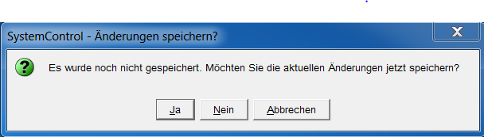

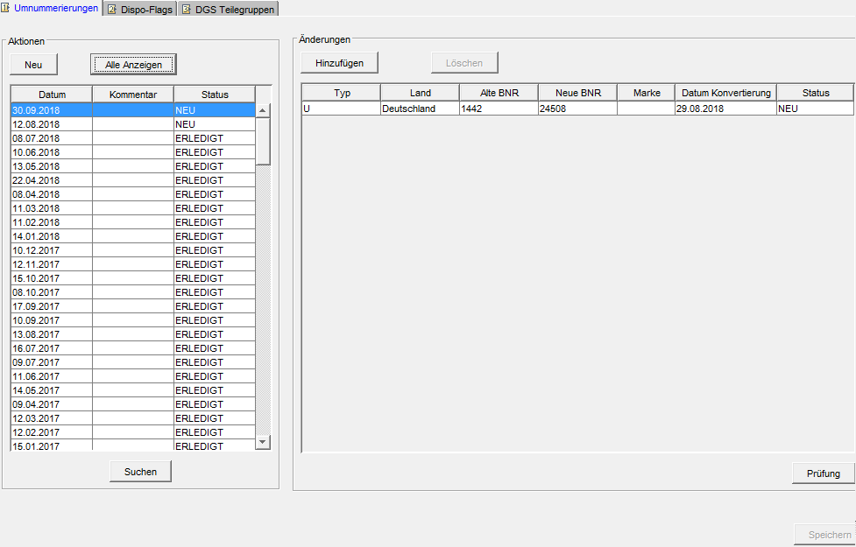

With the help of the "Search" button, only those actions can be displayed in the list in which a specific company was involved. The "Show all" button switches back to the complete view.

## Implementation in general

Read all renumberings on this date with the same step number, sorted by step and type.

**Testing:**

* each dealer number (old and new) occurs only with one type
* For all types, the new dealer number must already be listed in the GSSN, the check is similar to the creation of new dealers
* for type "U", a BNR cannot appear more than once for old or new
* with type "T" a BNR cannot appear more than once for new
* For type "T", a BNR can only appear once for old and new at the same time
* with type "T" a brand cannot appear more than once (for the same old BNR)
* with type "Z" a BNR cannot appear more than once with old

**Defer all FK constraints in the DIMS schema (for the session) and disable all triggers in the database.**

**Renumbering for type "U"**

Get next renumbering block (next entry or chain)

Trigger Ring-chain

Update all concerned tables

Mark renumbering block as executed and execute commit

**Renumbering for type "T**

Get next renumbering block (entries with same old location)

Update all concerned tables

Mark renumbering block as executed and execute commit

**Renumbering for type "Z**

Get next renumbering block (entries with same new location)

Update all concerned tables

Delete all forecasts and planned orders for the locations

Set Dispo indicator for full assortment

Mark renumbering block as executed and execute commit

**Mark renumbering action as performed**

**Enable all triggers.**

## Implementation in 2 steps

By performing renumbering in 2 steps, separations and mergers can be booked for one operation in one pass.

Example:

Brand PKW should be separated from dealer 4711 and integrated into dealer 4712.

The following steps are necessary for this:

Step 1: Separation of the brand PKW in dummy dealer

Step 2: Merging the dummy dealer and dealer 4712

It is not possible to record these two sub-processes via the GUI. Therefore, the following procedure is necessary:

1. Creation of a dummy dealer for separation in the GSSN pool (manually by T-Systems)
2. Recording of all renumberings (separation, renumbering, mergers) at the GUI, which are to be booked in the first step
3. Recording of all mergers (step 2), which for the separated dealer directly in the database. After that, no more changes to the GUI are possible.

The renumbering entered in this way can be booked completely without the renumbering processes having to be interrupted or terminated by the computer operation in between.

Clustering after merging is performed for all dealers for which merging has been performed.

By clustering, the SALES_BASIC_DATA table is also implicitly completely rebuilt for the new operation.

## Renumbering from VP to NDL

The contract partners and branches in Germany have different suffixes for the system identifiers. If a CP is now renumbered to an NDL, it sends to a different basket from this point on. Therefore, a different system identifier is used during import.

The suffix of the system identifier changes from 094 (CPI) to 095 (FAKET). During renumbering, an entry is therefore created in the System identifier table for the new FAKET system identifier.

In all other countries, subsidiaries and contractors use the same suffix. Thus, no modification is necessary here.

## Renumbering of Interim Process

The date of renumbering (updating of the location numbers in the DB tables) does not correspond to the actual date on which a dealer receives a new number. Therefore, import files are currently buffered or export files are still exported under the old dealer number during this transition period.

The interim renumbering process will now automatically convert the import and export files so that the renumbering is already effective externally. Internally, however, the old company numbers are still being used.

The interim process starts with the entry of a renumbering on the GUI and ends automatically on the day of renumbering. The interim process can only be applied to the type U renumbering, in case of separation or merging this process is not relevant.

To control the start time of the file conversion, the DATUM_ KONVERTIERUNG field is added to the UMNUMMERIERUNGEN table.

With Release 53, a new column "Datum Konvertierung" is added to the renumbering dialog. The start of the automatic conversion can be entered here. An entry in this field is only possible for renumbering type U.

By default, the interim process is not active, i.e., the Date conversion field is empty.

It should be noted that the customer numbers in the Dealer Data panel are maintained accordingly when the interim process is active.

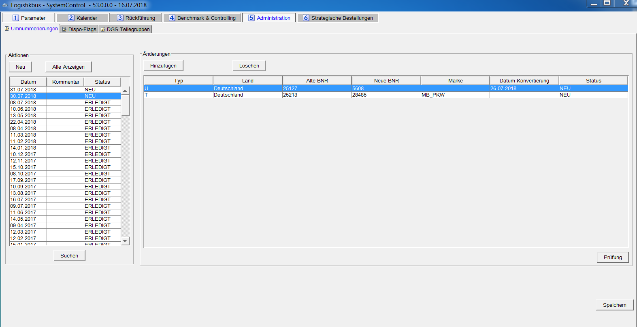

## Optimization of runtimes

The dealer numbers that are changed during renumbering are contained in many tables as keys and are then referenced by other tables as foreign key (FK) constraints. To keep the implementation simple, all FK constraints were disabled at the beginning of a renumbering and enabled again at the end. When enabling the constraints, the database checked ALL records of the affected tables. In particular since also some "large" tables are affected by it (e.g. KONTEN, KONNEKTOREN, INBOUND, OUTBOUND, etc.) the run time for the enabling of the constraints became ever longer. A large part of the total runtime is now spent on enabling the constraints and not on the actual renumbering.

Example from 12.04.2020 (only one dealer was renumbered):

Start renumbering dealers 08:14

End renumbering dealers 08:39

Running time renumbering dealers 25 min

Enable Start FK Constraints 08:39

Enable End FK Constraints 13:29

Enable Runtime Constraints 290 min

I.e., instead of a runtime of less than 30 minutes, over 5 hours were required. With each further rollout, the size of these tables increases (this is only limited by archiving or deleting old data but cannot be compensated by this). Therefore, the runtime has continued to increase accordingly over the last few years (and would continue to do so).

In order not to have to make any changes to the actual process, the FK constraints will no longer be disabled but only deferred. This means that the constraint remains enabled, but the constraints are not validated until the commit (i.e., at the end of the renumbering it is still ensured that all constraints are valid). The constraints are only deferred for the DIMS schema and only during renumbering (limited to the DB session of renumbering). I.e., all other processes are not affected. To enable this, however, the FK constraints in the DIMS schema must be dropped once and recreated as deferrable (this is done via DB script with the release for the affected 96 constraints).

1. Implementation

## Database

Table BETRIEBSDATEN_KONZERN

|  |  |  |  |  |
| --- | --- | --- | --- | --- |
| Column | Column name | Type | Key | Description |
| 1 | GORT | NUMBER(14) | PK | Global location (dealer number) |
| 2 | NAME | VARCHAR2(400) |  | Full name of the dealer |
| 3 | STRASSE | VARCHAR2(200) |  | Street (incl. house number) |
| 4 | HAUSNUMMER | VARCHAR2(10) |  | House number (not used) |
| 5 | PLZ | VARCHAR2(40) |  | Postal code |
| 6 | STADT | VARCHAR2(100) |  | City |
| 7 | TELEFON | VARCHAR2(100) |  | Phone number |
| 8 | FAX | VARCHAR2(100) |  | Fax number |
| 9 | EMAIL | VARCHAR2(100) |  | Mail address |
| 10 | WEB | VARCHAR2(100) |  | Web address |
| 11 | KZ_AKTIV | NUMBER(1) |  | Dealer active indicator (from GSSN) |
| 12 | TYP | VARCHAR2(100) |  | Dealer type, e.g., "Branch" |
| 13 | KZ_HB | VARCHAR2(1) |  | Main dealer indicator (Y Operation / N) |
| 14 | HB_NR | NUMBER(14) |  | Dealer number of the main dealer (if KZ_HB = 'N', GORT) |
| 15 | DIMS_STATUS | NUMBER(1) |  | Status for DIMS (1 for active, 0 for inactive) |
| 16 | DIMS_STATUS_AB | DATE |  | Validity date of the status (before the date, status is exactly the opposite). |
| 17 | LIEFERANT_RF_V | NUMBER(6) |  | Supplier RFV |
| 18 | BENUTZER_RF_V | VARCHAR2(25) |  | User RFV |
| 19 | DATUM_START_AP | DATE |  | Start automatic return |
| 20 | DATUM_START_AP_ALT | DATE |  | Start automatic return old |
| 21 | KZ_PROZESS_STEUERUNG | VARCHAR2(8) |  | Process control indicator |
| 22 | KZ_BESTANDS_IMPORT | VARCHAR2(1) |  | Stock import indicator (D, S, C, N) |
| 23 | AEDAT | DATE |  | Modification date |
| 24 | STOX_AKTIV | VARCHAR2(2) |  | DeadStock Active (Y / N), D2D Active (Y / N) |
| 25 | STOX_INIT | VARCHAR2(2) |  | DeadStock Initialization (Y / N) D2D Initialization (Y / N) |
| 26 | GPS_X_GSSN | VARCHAR2(20) |  | GPS X coordinates from GSSN |
| 27 | GPS_Y_GSSN | VARCHAR2(20) |  | GPS Y coordinates from GSSN |
| 28 | GPS_X_GEODEC | NUMBER(14,10) |  | GPS X coordinates GEODEC |
| 29 | GPS_Y_GEODEC | NUMBER(14,10) |  | GPS Y coordinates GEODEC |
| 30 | CORS_PROCESS | VARCHAR2(1) |  | CORS process (R / D) |
| 31 | KAL_RF | NUMBER(5) |  | Calendar for return |
| 32 | KZ_ICT_LER | VARCHAR2(1) |  | ICT indicator for LER files |
| 33 | DMS | VARCHAR2(20) |  | Dealer Management System |
| 34 | DMS_VERSION | VARCHAR2(20) |  | Version of the Dealer Management System |
| 35 | JCFR_AKTIV | VARCHAR2(10) |  | JCFR indicator |
| 36 | HAENDLER_GRUPPE | VARCHAR2(50) |  | Dealer group |
| 37 | COMPANY_ID_GSSN | VARCHAR2(20) |  | Company Id from GSSN |
| 38 | ZEITZONE | VARCHAR2(10) |  | Time zone of the dealer (abbreviation of the time zone, e.g., CET, EST, PST, etc.) |
| 39 | DATUM_START_MBCS | DATE |  | Start of project MBCS return |
| 40 | DATUM_START_MBCS_ALT | DATE |  | Start of project MBCS return old |

A pool table is inserted for the dealers already listed in the GSSN, which are not yet included in the dealer data. The structure of this table is similar to the table BETRIEBSDATEN_KONZERN (exception: GORT is not a reference to the GLOBALE_ORTE) table, but it includes only the GSSN fields.

Table GSSN_POOL

|  |  |  |  |  |
| --- | --- | --- | --- | --- |
| Column | Column name | Type | Key | Description |
| 1 | GORT | NUMBER(14) | PK | Global location (dealer number) |
| 2 | NAME | VARCHAR2(400) |  | Full name of the dealer |
| 3 | STRASSE | VARCHAR2(200) |  | Street (incl. house number) |
| 4 | HAUSNUMMER | VARCHAR2(10) |  | House number (not used) |
| 5 | PLZ | VARCHAR2(40) |  | Postal code |
| 6 | STADT | VARCHAR2(100) |  | City |
| 7 | TELEFON | VARCHAR2(100) |  | Phone number |
| 8 | FAX | VARCHAR2(100) |  | Fax number |
| 9 | EMAIL | VARCHAR2(100) |  | Mail address |
| 10 | WEB | VARCHAR2(100) |  | Web address |
| 11 | KZ_AKTIV | NUMBER(1) |  | Dealer active indicator (from GSSN) |
| 12 | TYP | VARCHAR2(100) |  | Dealer type, e.g., "Branch" |
| 13 | KZ_HB | VARCHAR2(1) |  | Main dealer indicator (Y / N) |
| 14 | HB_NR | NUMBER(14) |  | Dealer number of the main dealer (if KZ_HB = 'N', GORT) |
| 15 | GPS_X_GSSN | VARCHAR2(20) |  | GPS X coordinates from GSSN |
| 16 | GPS_Y_GSSN | VARCHAR2(20) |  | GPS Y coordinates from GSSN |
| 17 | GPS_X_GEODEC | NUMBER(14,10) |  | GPS X coordinates GEODEC |
| 18 | GPS_Y_GEODEC | NUMBER(14,10) |  | GPS Y coordinates GEODEC |
| 19 | COMPANY_ID_GSSN | VARCHAR2(20) |  | Company Id from GSSN |
| 20 | AEDAT | DATE |  | Modification date |

Table BETRIEBSDATEN_FREMD (the external suppliers are entered here)

|  |  |  |  |
| --- | --- | --- | --- |
| Column name | Type | Key | Description |
| **GORT** | NUMBER(14) | PK | Global location (dealer number) which belongs to the third-party supplier |
| **LIEFNR** | NUMBER(14) | PK | Number of the external dealer |
| **KNR** | VARCHAR2(14) |  | Customer number of the dealer at the external supplier |
| **NAME** | VARCHAR2(100) |  | Dealer name |
| **STRASSE** | VARCHAR2(30) |  | Street |
| **HAUSNUMMER** | VARCHAR2(10) |  | House number (Eg. 85-87) |
| **PLZ** | NUMBER(10) |  | Postal code |
| **STADT** | VARCHAR2(30) |  | City |
| **TELEFON** | VARCHAR2(20) |  | Phone number |
| **FAX** | VARCHAR2(20) |  | Fax number |
| **EMAIL** | VARCHAR2(40) |  | Mail address |

Table KUNDEN_NUMMERN

|  |  |  |  |
| --- | --- | --- | --- |
| Column name | Type | Key | Description |
| **GORT** | NUMBER(14) | PK |  |
| **MARKE** | VARCHAR2(20) | PK |  |
| **TEILEGRUPPE** | NUMBER(4) | PK |  |
| **KUNDEN_NUMMER** | NUMBER(10) |  |  |
| **BRANCH_NUMMER** | NUMBER(10) |  |  |
| **LIEFERANTEN_NUMMER_RUV** | NUMBER(10) |  |  |

Table UMNUMMERIERUNG_AKTIONEN

|  |  |  |  |
| --- | --- | --- | --- |
| Column name | Type | Key | Description |
| **UMN_ISN** | NUMBER(14) | PK | Sequence number for this renumbering |
| **KOMMENTAR** | VARCHAR2(100) |  | Description of renumbering |
| **DATUM** | DATE |  | Date on which the renumbering is to be performed. |
| **STATUS** | NUMBER(1) |  | Status (planned, fully implemented, partially implemented) |

Table UMNUMMERIERUNGEN

|  |  |  |  |
| --- | --- | --- | --- |
| Column name | Type | Key | Description |
| **UMN_ISN** | NUMBER(14) | FK | Associated renumbering action |
| **TYP** | VARCHAR2(1) |  | Type of renumbering ('U', 'T', 'Z') |
| **GORT_ALT** | NUMBER(14) | PK | Old global location |
| **GORT_ NEU** | NUMBER(14) | PK | New global location |
| **MARKE** | VARCHAR(20) |  | Brand (set only in case of separation) |
| **STATUS** | NUMBER(1) |  | Status (planned, ok, error) |
| **SCHRITT** | NUMBER(1) |  | Processing step |
| **DATUM_KONVERTIERUNG** | DATE |  | Date when the conversion of the files (import / export) starts |

1. Annex

## Identification of the main and connected dealer

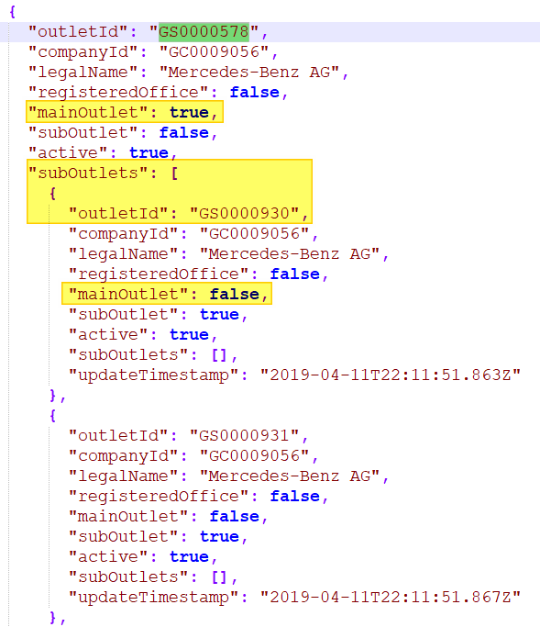

Figure 6‑1Example of market structure for the German market (Market View )

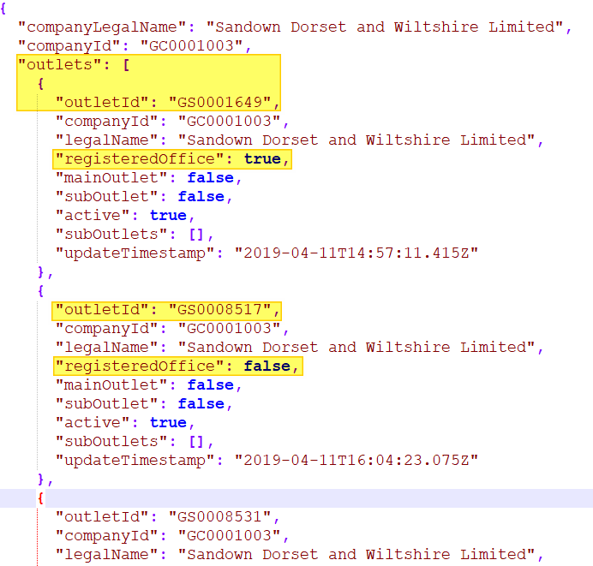

Figure 6‑2Example of market structure for the UK market (Legal View)

## GSSN+ API request with brand code: /v1/outlets/search

Post Body:

{

"countryIsoCodes": [

"DE"

],

"externalKeys": [

{

"type": "BRAND-CODE",

"value": "00311"

}

],

"includeApplicants": false,

"onlyActive": false

}

1. Application-ID DIMSBATCH, Key imp.betriebsdaten.GssnConverter.MARKET_VIEW_COUNTRIES.
2. See also the DP concept R34P - GSSN local conversion.